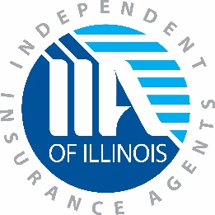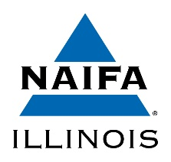

March 20, 2020
Honorable JB Pritzker Honorable Robert Muriel
Governor Director
State of Illinois Illinois Department of Insurance
207 State House 320 W. Washington St.
Springfield, IL 62706 Springfield, IL 62701

Dear Governor Pritzker and Director Muriel,
Our nation is facing extraordinary times as a result of the COVID-19 pandemic, and while the full impact remains unknown, Illinois’ insurance consumers are certain to face significant challenges. As you continue to make important decisions during the novel coronavirus pandemic, please consider the following proposals aimed at protecting consumers during these uncertain times.
Protect Illinois Consumers:
As Illinois considers mandating “shelter-in-place” procedures other than for essential business, the Coalition of Insurance Agents and Brokers respectfully request this includes insurance agencies and producers be considered “essential business, employees, and entities” within the terms of essential services provided to the public, which include:
- Receiving first reports from policyholders of incidents for which they make claims against their insurance coverages;
- Acting as intermediaries between insurance claimants and the insurers providing coverages;
- Obtaining insurance for businesses and households in immediate need of coverage (for example, individuals who must quickly obtain Homeowners Insurance for closings on home mortgage loans);
- Issuing Automobile Liability Insurance identification cards for purchasers of new and used motor vehicles, who must produce the cards to the Secretary of State at the time of vehicle registration;
- As well as, accepting premium payments from the public.
Collectively, we ask that you deem insurance agencies and producers to be “essential businesses, employees, and entities providing essential services or functions” and not subject to a mandated “shelter-in-place” order. Insurance policyholders rely on their agents and producers to provide services whenever they need them.
Consequently, it is critical that agencies and brokerages have sufficient staff on hand to provide these services. It is imperative that agencies have the flexibility to determine the right staffing plan for their business, one that allows for safety of employees while serving the needs of their customers.
Moratorium on Cancellation and Non-Renewal Notices:
In a previous message to Director Muriel, we requested an imposition of an insurer moratorium on commercial policy cancellation and non-renewals during the pandemic declaration. We believe this must extend to all lines of insurance policy cancellations and non-renewals as well as commercial and individual policies. It is common practice that Illinois routinely issues during times of disaster declarations. We believe such an announcement will provide consumers with some level of certainty regarding their personal or business coverage during this extreme time of uncertainty. Like past moratoriums, we would recommend this take effect with the date of the Governor’s Executive Order dating back to March 9, 2020.
Protect Illinois’ Access to Trusted Advice and Support:
Insurance Agents and brokers are their policyholders’ strongest advocates and best source of trusted advice. Illinois policyholders must be able to count on this support during the pandemic and its aftermath. In light of restrictions on gatherings and travel, social distancing recommendations, and direct and indirect health aspects, insurance agents and brokers will face increased difficulty in obtaining the required continuing education credits and renewing their individual and corporate licenses. As such, we ask the Department to grant a grace period for CE and license renewal requirements for the duration of the current State of Emergency. Additionally, we would ask that you allow continuing education courses filed as classroom be able to be presented in a webinar format without having to re-file the class with the Department.
Collectively, these measures will help protect Illinois policyholders during their time of greatest need. We stand ready and willing to assist Governor Pritzker, his administration, and the Illinois Department of insurance in any way necessary.

Sincerely,
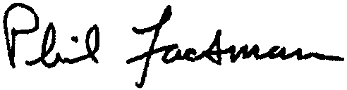
Phil Lackman, CEO Joshua Garrett, State Legislative Director
IIA of IL ISAHU

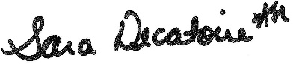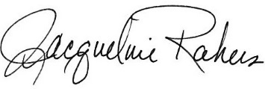
Sara Decatoire, CAE, Executive Director Jackie Rakers, IOM, PFMM
NAIFA – IL IAMIC

