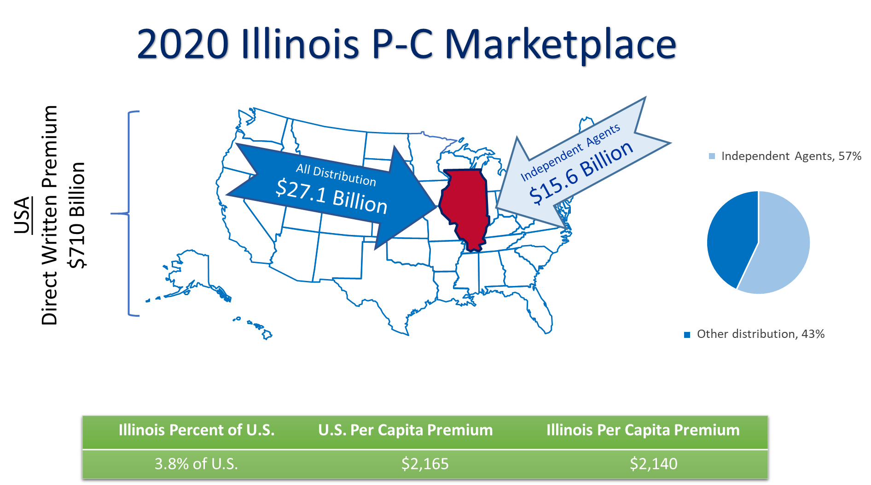
Source: © A.M. Best Company — Used by Permission; US Census Bureau
You are being provided this summary of the Illinois property and casualty (P-C) insurance marketplace as a benefit of your membership in the Independent Insurance Agents of Illinois.
What follows is a numeric and visual summary of the P-C insurance marketplace from an independent agent’s perspective in Illinois.
- Illinois summary: premium and distribution by line of business (L.O.B.)
- Loss ratios by L.O.B.
- Average growth rates by L.O.B.
- Top nine lines of business: five years of premium, penetration, loss ratios and top insurers
- Independent agent penetration: five-year trends by L.O.B.
- Average commissions: major L.O.B.s
- Surplus Lines: surplus lines utilization and top L.O.B.s written
- Fire and Allied Lines Breakout
- Policy Dividends Breakout
- Appendices with information on data sources, approaches and definitions.

Illinois: All L.O.B.s: Premium and Distribution (Alphabetical)
2020 Illinois Direct Written Premium (DPW in $Millions)
Major Line of Business (L.O.B.) | (1)  All Distribution | (2)  Pure IA or Broker DPW | (3)  MGA/  Wholesale  DPW | (4)  IA-Mixed DPW | (5)  Exclusive-Captive DPW | (6)  Direct DPW | (7)  Other | (2+3+4)÷(1) IA Penetration
Aggregate Write-ins | $32 | $8 | $4 | $0 | $2 | $16 | $2 | 38%
Aircraft (all perils) | $79 | $73 | $2 | $0 | $0 | $3 | $0 | 96%
All Commercial Auto | $1,902 | $1,351 | $192 | $27 | $199 | $98 | $35 | 83%
All Private Passenger Auto | $7,620 | $1,674 | $193 | $90 | $4,165 | $1,498 | $0 | 26%
Boiler & Machinery | $83 | $54 | $0 | $26 | $1 | $3 | $0 | 96%
Burglary & Theft | $25 | $22 | $1 | $2 | $0 | $0 | $0 | 98%
Commercial Multi-Peril | $1,886 | $1,404 | $49 | $50 | $332 | $39 | $12 | 80%
Credit | $78 | $48 | $7 | $0 | $18 | $5 | $0 | 71%
Excess Workers' Comp | $60 | $56 | $2 | $0 | $0 | $2 | $0 | 96%
Farmowners Multi-Peril | $206 | $42 | $1 | $0 | $140 | $14 | $9 | 21%
Fidelity | $72 | $64 | $2 | $0 | $1 | $4 | $1 | 92%
Financial Guaranty | $10 | $0 | $0 | $0 | $0 | $5 | $5 | 0%
Fire & Allied Lines | $1,800 | $1,078 | $242 | $256 | $153 | $66 | $7 | 87%
Homeowners Multi-Peril | $4,119 | $1,228 | $117 | $75 | $2,303 | $382 | $15 | 34%
Inland Marine | $906 | $565 | $66 | $57 | $187 | $30 | $1 | 76%
Medical Malpractice | $478 | $163 | $55 | $212 | $11 | $25 | $11 | 90%
Mortgage Guaranty | $248 | $50 | $0 | $0 | $0 | $143 | $55 | 20%
Ocean Marine | $135 | $125 | $6 | $1 | $0 | $3 | $0 | 98%
Other Liability (Claims-made) | $1,521 | $1,286 | $88 | $9 | $17 | $54 | $67 | 91%
Other Liability (Occurrence) | $2,980 | $1,724 | $130 | $781 | $170 | $112 | $63 | 88%
Products Liability | $194 | $168 | $13 | $0 | $5 | $6 | $3 | 93%
Surety | $236 | $173 | $34 | $1 | $2 | $24 | $2 | 88%
Warranty | $230 | $81 | $0 | $0 | $123 | $17 | $10 | 35%
Workers' Compensation | $2,216 | $1,822 | $45 | $47 | $116 | $122 | $64 | 86%
TTL Grps I+II (All Typical Lines) | $27,117 | $13,257 | $1,249 | $1,635 | $7,945 | $2,669 | $363 | 60%
Source: © A.M. Best Company — used by permission.
Notes or Comments: The “Lines of Business” (L.O.B.) listed above are taken from an annual statement page each insurer must file with their state regulator. Regulators require 34 lines of business break-outs from insurers in every state where business is written. Some L.O.B.s above are actually combinations of L.O.B.s. An example of a combination is the data on personal automobile liability is combined with physical damage and other coverages. Of the 34 lines of business, the 24 shown above are included in many industry summaries. For the remainder of this summary, 19 of the above 24 are focused on as the most relevant to Independent agents. Not focused on is Aggregate Write-ins, credit-related coverages, financial guaranty, mortgage guaranty and warranties.
The classification of insurers using independent agents (IAs), brokers, MGAs, etc. are based on what is reported by the insurers. When combinations of marketing or distribution are reported for a single insurer, insurers are put in the category that best seems to fit. The above table shows the estimated premium distribution through independent agents, MGAs and IA-mixed distribution is 60%. That is the higher then shown on the first page for independent agents. The first page uses A.M. Best’s estimate of independent agent distribution as provided in their standard industry reports. The above classifications are based on a more specific and proprietary approach employed for this summary as applied to each policy-issuing insurer. The two approaches are generally close. More information on classifying by Marketing Type or distribution style insurers is included in an appendix.

Illinois: Loss Ratios: 2020 and 5-Year Average
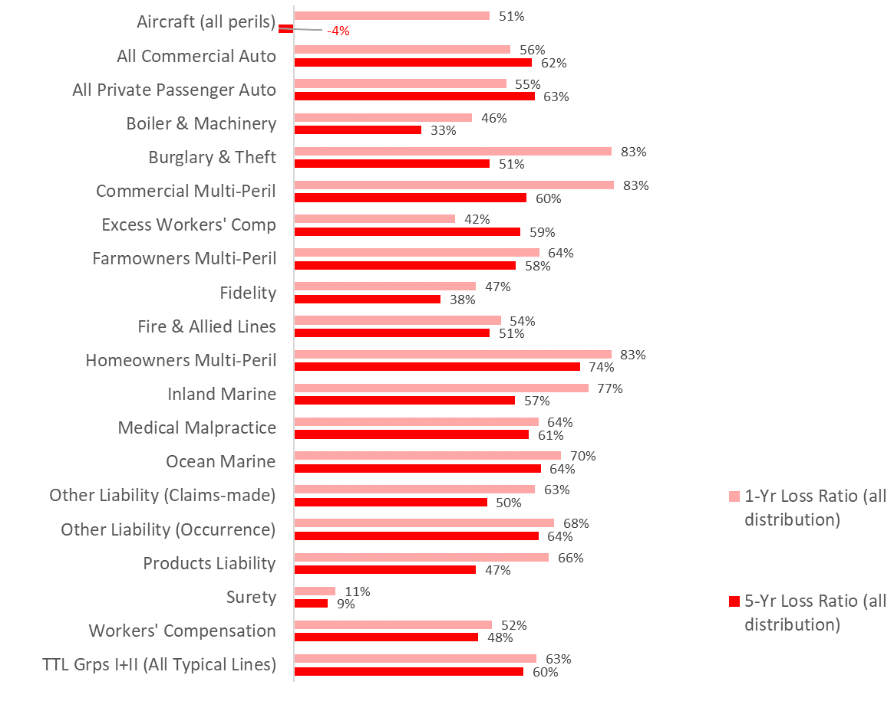
Source: © A.M. Best Company — used by permission.
Notes or Comments:
$$Calendar Year Loss Ratio=\frac{Paid Losses+New Reserves±Changes in Prior Reserves}{Earned Premiums-Policy Dividends}$$
Loss ratios in this summary are calculated as “adjusted calendar year loss ratios” (see formula). This means for each L.O.B. the losses used in the ratio of losses to earned premiums are the paid losses that year, plus any estimates of future losses that will be paid from claims that year (also known as "reserves") plus any changes in "reserves" from prior years. The "adjusted" part is if dividends are paid out under an L.O.B., the loss ratio is adjusted for that cost. When dividends paid out are a minor factor, an adjusted and unadjusted loss ratio is nearly the same but, where dividends are an important component, it is important to include them in the calculation. The one-year and five-year average loss ratios are provided above. That can show trends or developments but it is also helpful to refer to the data for all five years for the top L.O.B.s provided later in this summary.

Illinois: Premium Growth Rates: 1-Year and 5-Year Average
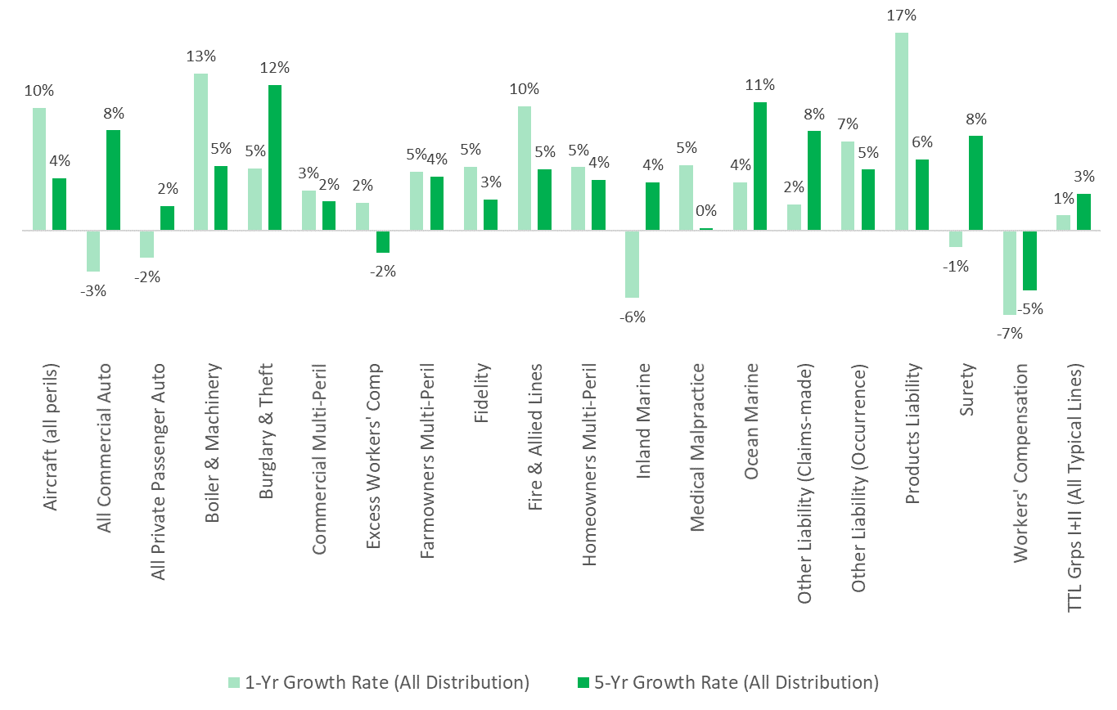
Source: © A.M. Best Company — used by permission.
Notes or Comments: Direct written premium growth rates are shown above. The five-year growth rate is, mathematically, the constant percentage for 2016 direct written premiums to exactly equal the direct written premium in 2020 when applied annually for the five annual periods on a compounded basis. The one-year percentage is the change in premiums from 2019 to 2020. As this single growth figure does not show variability between years it is also helpful to examine premium trends by reviewing all years sequentially as can be seen for the top lines of business later in this summary.

Illinois: Ranking the L.O.B.s
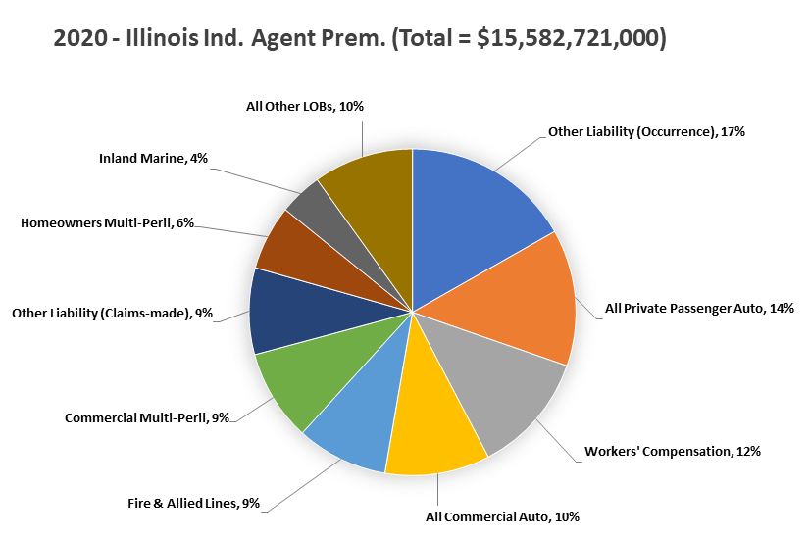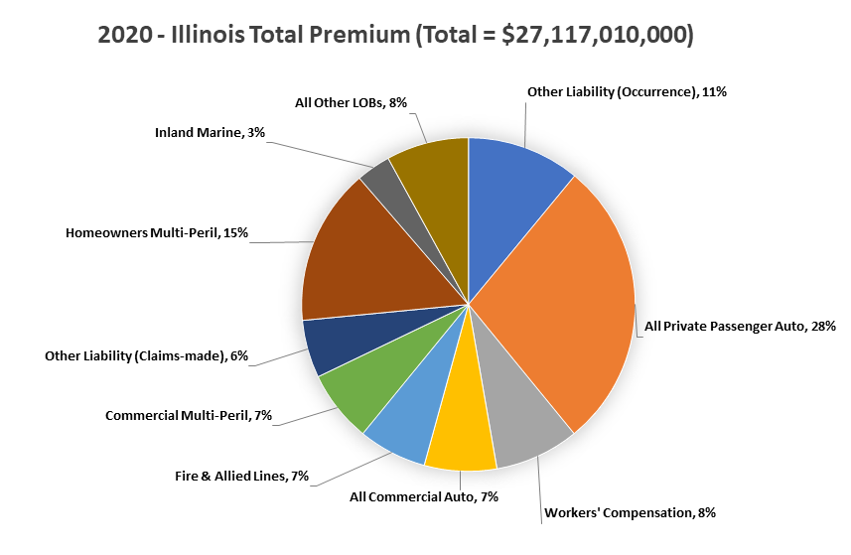
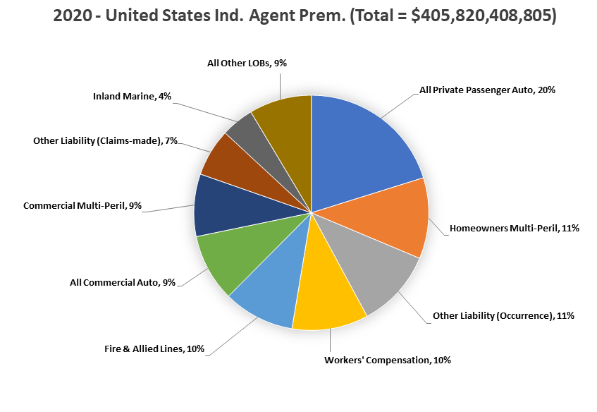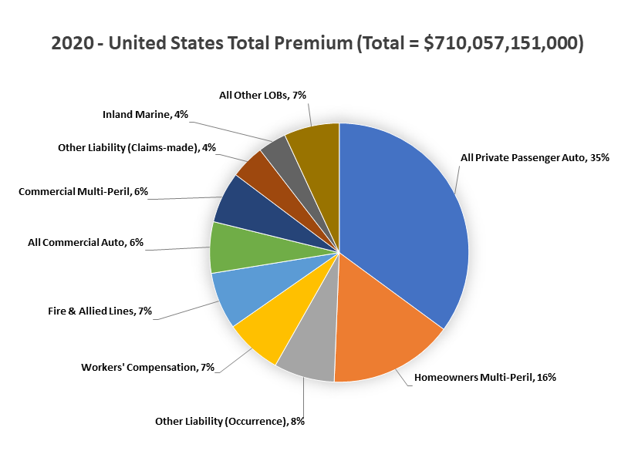
Source: © A.M. Best Company — used by permission.
Notes or Comments: Above, the upper, left-hand pie chart shows the top lines of business (L.O.B.s), in order of premium written by Illinois independent agents. The right-hand chart shows the premiums written for those lines when all forms are distribution are included. The bottom two pie charts are for comparison but those are in rank order as written by independent agents in all states combined. The independent agent portion of premiums for each L.O.B. in these charts is that determined by A.M. Best in their standard industry reports.

Illinois: Largest Independent Agent L.O.B.s
Following is more detail on each of the top nine Lines of Business (L.O.B.s) in Illinois for the years 2016 to 2020. All lines are combined, in aggregate, in the tenth summary. That is the top nine plus any other L.O.B. of significance to independent agents. The order of the L.O.B.s presented is the ranking, by premium volume, as written by independent agents in Illinois.
Provided for each major line of business are:
- A summary graph of five-years data on premiums for all distribution types (dark blue), premiums written through independent agents (light blue) and loss ratios (red line). For these graphs the delineation of premiums through Independent Agents is that of A.M. Best in their standard industry reports
- The average premium trend for all distribution and through independent insurance agents
- The portion of premiums written though U.S.-domiciled surplus lines insurers
- The average five-year combined ratio
- The number of active insurer groups and policy-issuing insurers in Illinois
- Top Insurers: The top five groups and the market share of that line of business by those groups is provided. This includes all premiums and all distributions combined for each group. Also provided is top ten top policy-issuing insurers using independent agencies/brokers, the top three MGA-focused, captive, exclusive or direct insurers and the top surplus lines insurers. Added, as well, is the largest premium writing risk retention group, if applicable for that line of business. For each insurer, average commission rates and adjusted loss ratios are provided as is any parent group or fleet.
As you scroll through the pages, watch for the visual que in the heading where you are in the ranking of premiums written by independent agents. Those are visually designated with a small pie chart and expanded slice is where the product is in the ranking. Below is personal automobile as an example when it is the largest line of business for a state.
Example L.O.B. Heading=>

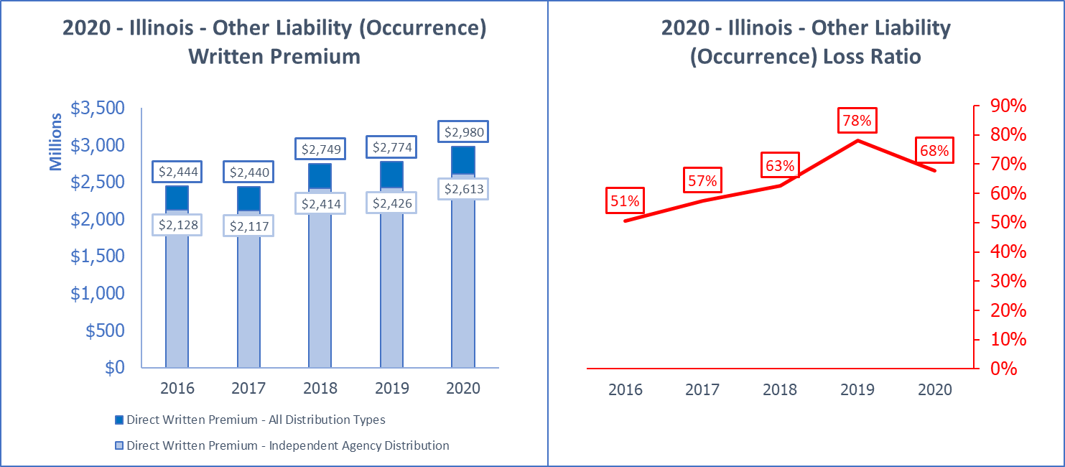
2020 - Illinois - Other Liability (Occurrence) Average Penetration: 87.4%
All Distribution Trend (DPW) | Ind. Agent Trend (DPW) | 5 yr. Loss Adj. Ratio | 5 yr. Combined Ratio | Domestic Surplus Lines ÷ ALL DPW
5.1% | 5.3% | 64% | 96% | 17.75%
Active Groups |Pol. Issuing | S.L. | RRGs => | Groups: 141 | Affil+Unaffil: 580 | S.L. Insurers: 114 | RRGs: 25
Top 5 Groups or Unaffil. [Mkt Share%] | 2020 DPW | 2020 Adj. Loss Ratio | 2020 Commission | Group Name or ALL L.O.B. DPW
Assurant P&C Group (G) [26.7%] | $796,213,000 | 58% | N/A | $889,286,000
Chubb INA Group (G) [8.5%] | $253,447,000 | 84% | N/A | $967,156,000
CNA Ins Cos (G) [6.4%] | $190,047,000 | 115% | N/A | $632,876,000
Travelers Group (G) [3.3%] | $98,976,000 | 70% | N/A | $1,206,490,000
Liberty Mutual Ins Cos (G) [2.9%] | $85,160,000 | 87% | N/A | $1,019,564,000
L.O.B. Total or Industry Ave. | $2,979,891,000 | 68% | 9.3% | $27,117,046,000
Top 10 IA Insurers
National Fire Insurance Co of Hartford | $95,427,000 | 81.0% | 5.9% | CNA Ins Cos
Indemnity Insurance Co of North America | $90,537,000 | 95.4% | 0.7% | Chubb INA Group
Travelers Property Casualty Co of Amer | $72,062,000 | 61.9% | 11.2% | Travelers Group
Continental Casualty Company | $63,257,000 | 188.2% | 0.7% | CNA Ins Cos
Federal Insurance Company | $38,785,000 | 64.8% | 17.3% | Chubb INA Group
ACE Property and Casualty Insurance Co | $38,472,000 | 136.1% | 4.6% | Chubb INA Group
Cincinnati Insurance Company | $37,634,000 | 20.7% | 18.2% | The Cincinnati Ins Cos
National Fire & Marine Insurance Co | $36,914,000 | 64.5% | 7.7% | Berkshire Hathaway Ins Grp
West Bend Mutual Insurance Company | $35,665,000 | 55.0% | 18.0% | ...
Zurich American Insurance Company | $33,361,000 | 52.5% | 6.4% | Zurich Insurance US PC Group
Top 3 MGA/Wholesale Insurers
Gemini Insurance Company | $28,915,000 | 51.5% | 12.8% | W. R. Berkley Ins Grp
Evanston Insurance Company | $26,145,000 | 13.9% | 17.9% | Markel Corporation Group
Securian Casualty Company | $10,160,000 | 65.8% | 24.5% | ...
Top 3 Captive-Exclusive and Direct Insurers
State Farm Fire and Casualty Company | $56,166,000 | 29.9% | 11.7% | State Farm Group
COUNTRY Mutual Insurance Company | $37,230,000 | 74.2% | 11.5% | COUNTRY Financial Propy Cas Grp
CUMIS Insurance Society, Inc. | $16,405,000 | 63.6% | 0.0% | CUMIS Insurance Society Group
Top 3 Surplus Lines Insurers
National Fire & Marine Insurance Co | $36,914,000 | 64.5% | 7.7% | Berkshire Hathaway Ins Grp
Gemini Insurance Company | $28,915,000 | 51.5% | 12.8% | W. R. Berkley Ins Grp
Evanston Insurance Company | $26,145,000 | 13.9% | 17.9% | Markel Corporation Group
Top RRG
United Educators Ins, a Reciprocal RRG | $6,778,000 | -5.3% | 0.8% | ...
Source: © A.M. Best Company — used by permission.
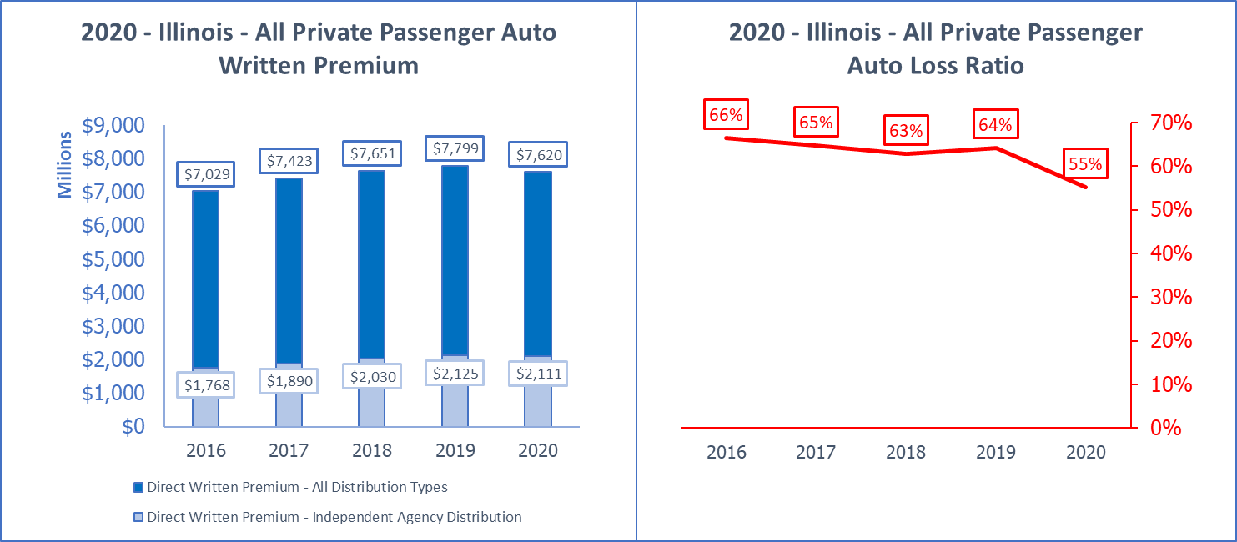
2020 - Illinois - All Private Passenger Auto Average Penetration: 26.4%
All Distribution Trend (DPW) | Ind. Agent Trend (DPW) | 5 yr. Loss Adj. Ratio | 5 yr. Combined Ratio | Domestic Surplus Lines ÷ ALL DPW
2.0% | 4.5% | 63% | 91% | 0.07%
Active Groups |Pol. Issuing | S.L. | RRGs => | Groups: 75 | Affil+Unaffil: 215 | S.L. Insurers: 1 | RRGs: 0
Top 5 Groups or Unaffil. [Mkt Share%] | 2020 DPW | 2020 Adj. Loss Ratio | 2020 Commission | Group Name or ALL L.O.B. DPW
State Farm Group (G) [29.2%] | $2,224,709,000 | 57% | N/A | $3,880,975,000
Allstate Ins Grp (G) [12.1%] | $919,247,000 | 49% | N/A | $1,745,216,000
Progressive Ins Grp (G) [8.8%] | $670,257,000 | 53% | N/A | $935,400,000
Berkshire Hathaway Ins Grp (G) [7.0%] | $536,205,000 | 64% | N/A | $909,761,000
COUNTRY Financial Prop Cas Grp (G) [6.8%] | $518,769,000 | 57% | N/A | $1,292,753,000
L.O.B. Total or Industry Ave. | $7,619,740,000 | 55% | 9.9% | $27,117,046,000
Top 10 IA Insurers
Progressive Northern Insurance Company | $289,616,000 | 54.4% | 10.6% | Progressive Ins Grp
Standard Fire Insurance Company | $121,512,000 | 53.1% | 13.7% | Travelers Group
Erie Insurance Exchange | $96,155,000 | 61.4% | 11.4% | Erie Ins Grp
Safeco Insurance Company of Illinois | $90,372,000 | 55.6% | 11.9% | Liberty Mutual Ins Cos
Owners Insurance Company | $78,041,000 | 56.9% | 16.8% | Auto-Owners Ins Grp
Farmers Automobile Insurance Assn | $75,002,000 | 55.2% | 15.0% | Pekin Ins Grp
American Access Casualty Company | $64,446,000 | 58.8% | 29.7% | Kemper PC Companies
American Alliance Casualty Company | $63,307,000 | 42.6% | 33.0% | ...
Trumbull Insurance Company | $55,730,000 | 56.6% | 0.0% | Hartford Ins Grp
Allmerica Financial Alliance Ins Co | $53,812,000 | 52.5% | 15.4% | Hanover Ins Group Prop & Cas Cos
Top 3 MGA/Wholesale Insurers
Liberty Mutual Personal Insurance Co | $76,917,000 | 76.9% | 0.7% | Liberty Mutual Ins Cos
Unique Insurance Company | $50,249,000 | 56.4% | 21.3% | Producers National Group
Viva Seguros Insurance Company | $28,958,000 | 65.9% | 29.1% | Producers National Group
Top 3 Captive-Exclusive and Direct Insurers
State Farm Mutual Automobile Ins Co | $2,121,983,000 | 56.5% | 9.6% | State Farm Group
Allstate Fire and Casualty Insurance Co | $649,371,000 | 49.7% | 11.6% | Allstate Ins Grp
GEICO Casualty Company | $429,480,000 | 65.7% | 1.0% | Berkshire Hathaway Ins Grp
Top 3 Surplus Lines Insurers
Stonegate Insurance Company | $4,957,000 | 63.2% | 25.6% | Producers National Group
None in L.O.B. | #N/A | #N/A | #N/A | #N/A
None in L.O.B. | #N/A | #N/A | #N/A | #N/A
Top RRG
None in L.O.B. | #N/A | #N/A | #N/A | #N/A
Source: © A.M. Best Company — used by permission.
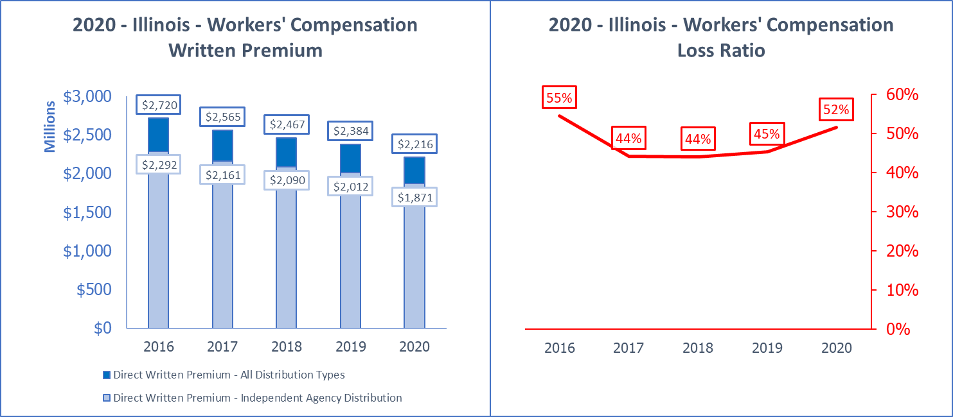
2020 - Illinois - Workers' Compensation Average Penetration: 84.4%
All Distribution Trend (DPW) | Ind. Agent Trend (DPW) | 5 yr. Loss Adj. Ratio | 5 yr. Combined Ratio | Domestic Surplus Lines ÷ ALL DPW
-5.0% | -5.0% | 48% | 78% | 0.13%
Active Groups |Pol. Issuing | S.L. | RRGs => | Groups: 99 | Affil+Unaffil: 353 | S.L. Insurers: 1 | RRGs: 0
Top 5 Groups or Unaffil. [Mkt Share%] | 2020 DPW | 2020 Adj. Loss Ratio | 2020 Commission | Group Name or ALL L.O.B. DPW
Travelers Group (G) [9.1%] | $201,116,000 | 61% | N/A | $1,206,490,000
Hartford Ins Grp (G) [7.2%] | $158,779,000 | 53% | N/A | $538,997,000
AF Group (G) [6.9%] | $153,493,000 | 64% | N/A | $163,054,000
Liberty Mutual Ins Cos (G) [5.7%] | $125,380,000 | 58% | N/A | $1,019,564,000
Chubb INA Group (G) [4.7%] | $103,443,000 | 19% | N/A | $967,156,000
L.O.B. Total or Industry Ave. | $2,216,164,000 | 52% | 8.3% | $27,117,046,000
Top 10 IA Insurers
Accident Fund Ins Co of America | $75,021,000 | 64.5% | 9.6% | AF Group
Zurich American Insurance Company | $69,360,000 | 64.4% | 2.4% | Zurich Insurance US PC Group
Pekin Insurance Company | $48,837,000 | 61.4% | 13.1% | Pekin Ins Grp
West Bend Mutual Insurance Company | $45,185,000 | 55.1% | 9.0% | ...
Accident Fund General Insurance Co | $44,516,000 | 41.8% | 8.7% | AF Group
Travelers Property Casualty Co of Amer | $41,900,000 | 43.4% | 6.6% | Travelers Group
Technology Insurance Company, Inc. | $41,622,000 | 61.4% | 7.0% | AmTrust Group
Phoenix Insurance Company | $36,621,000 | 60.8% | 10.1% | Travelers Group
Indemnity Insurance Co of North America | $30,610,000 | 26.1% | 0.6% | Chubb INA Group
Travelers Indemnity Co of America | $29,169,000 | 88.6% | 9.4% | Travelers Group
Top 3 MGA/Wholesale Insurers
State National Insurance Company, Inc. | $11,430,000 | 32.5% | 8.0% | Markel Corporation Group
Praetorian Insurance Company | $8,449,000 | 68.9% | 16.1% | QBE North America Ins Grp
Markel Insurance Company | $6,449,000 | 54.1% | 11.5% | Markel Corporation Group
Top 3 Captive-Exclusive and Direct Insurers
LM Insurance Corporation | $53,261,000 | 67.0% | 3.1% | Liberty Mutual Ins Cos
COUNTRY Mutual Insurance Company | $53,084,000 | 58.3% | 6.5% | COUNTRY Financial Propy Cas Grp
Liberty Mutual Fire Insurance Company | $18,475,000 | 47.1% | 7.7% | Liberty Mutual Ins Cos
Top 3 Surplus Lines Insurers
Illinois EMCASCO Insurance Company | $2,777,000 | 24.3% | 7.5% | EMC Ins Cos
None in L.O.B. | #N/A | #N/A | #N/A | #N/A
None in L.O.B. | #N/A | #N/A | #N/A | #N/A
Top RRG
None in L.O.B. | #N/A | #N/A | #N/A | #N/A
Source: © A.M. Best Company — used by permission.
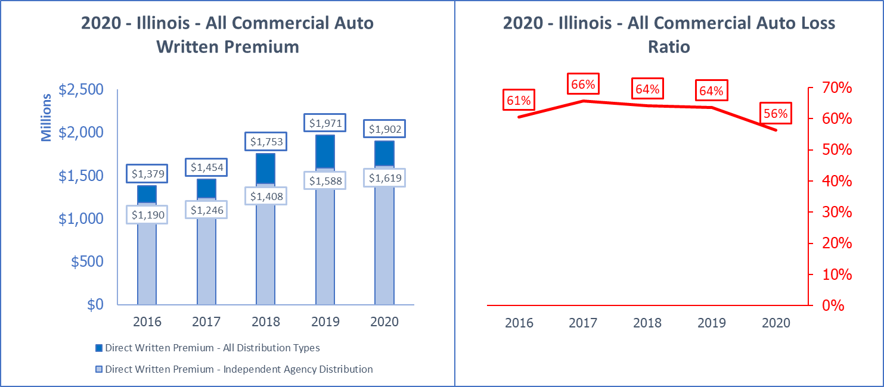
2020 - Illinois - All Commercial Auto Average Penetration: 83.6%
All Distribution Trend (DPW) | Ind. Agent Trend (DPW) | 5 yr. Loss Adj. Ratio | 5 yr. Combined Ratio | Domestic Surplus Lines ÷ ALL DPW
8.4% | 8.0% | 62% | 98% | 3.14%
Active Groups |Pol. Issuing | S.L. | RRGs => | Groups: 115 | Affil+Unaffil: 399 | S.L. Insurers: 49 | RRGs: 16
Top 5 Groups or Unaffil. [Mkt Share%] | 2020 DPW | 2020 Adj. Loss Ratio | 2020 Commission | Group Name or ALL L.O.B. DPW
Progressive Ins Grp (G) [11.1%] | $211,959,000 | 72% | N/A | $935,400,000
Travelers Group (G) [7.3%] | $137,944,000 | 49% | N/A | $1,206,490,000
Old Republic Ins Grp (G) [5.1%] | $97,131,000 | 61% | N/A | $227,925,000
Zurich Insurance US PC Group (G) [3.9%] | $74,777,000 | 49% | N/A | $552,156,000
Allstate Ins Grp (G) [3.8%] | $71,875,000 | 25% | N/A | $1,745,216,000
L.O.B. Total or Industry Ave. | $1,902,354,000 | 56% | 15.3% | $27,117,046,000
Top 10 IA Insurers
Artisan and Truckers Casualty Company | $151,079,000 | 45.4% | 9.4% | Progressive Ins Grp
Great West Casualty Company | $61,377,000 | 54.5% | 11.0% | Old Republic Ins Grp
Zurich American Insurance Company | $58,958,000 | 43.9% | 5.2% | Zurich Insurance US PC Group
Acuity, A Mutual Insurance Company | $56,095,000 | 49.7% | 14.3% | ...
TRANSGUARD INSURANCE COMPANY OF AMERICA | $50,969,000 | 39.4% | 23.0% | IAT Ins Grp
National Continental Insurance Company | $41,945,000 | 120.0% | 5.1% | Progressive Ins Grp
Pekin Insurance Company | $41,647,000 | 65.2% | 15.3% | Pekin Ins Grp
West Bend Mutual Insurance Company | $37,410,000 | 52.5% | 17.0% | ...
Owners Insurance Company | $31,721,000 | 57.4% | 16.0% | Auto-Owners Ins Grp
Erie Insurance Exchange | $29,503,000 | 64.9% | 11.2% | Erie Ins Grp
Top 3 MGA/Wholesale Insurers
Northland Insurance Company | $69,088,000 | 41.3% | 19.3% | Travelers Group
State National Insurance Company, Inc. | $21,587,000 | 69.3% | 19.8% | Markel Corporation Group
National Interstate Insurance Company | $16,463,000 | 44.8% | 8.0% | Great American P & C Ins Grp
Top 3 Captive-Exclusive and Direct Insurers
Allstate Insurance Company | $66,199,000 | 36.5% | 1.2% | Allstate Ins Grp
Sentry Select Insurance Company | $38,676,000 | 56.4% | 11.2% | Sentry Ins Grp
COUNTRY Mutual Insurance Company | $38,085,000 | 67.4% | 6.6% | COUNTRY Financial Propy Cas Grp
Top 3 Surplus Lines Insurers
Stonegate Insurance Company | $11,673,000 | 67.2% | 20.0% | Producers National Group
Lexington Insurance Company | $6,771,000 | 33.9% | 9.8% | American International Group
Third Coast Insurance Company | $6,175,000 | 74.5% | 9.0% | AF Group
Top RRG
Compass Specialty Insurance RRG, Inc. | $6,696,000 | 94.2% | 10.4% | ...
Source: © A.M. Best Company — used by permission.
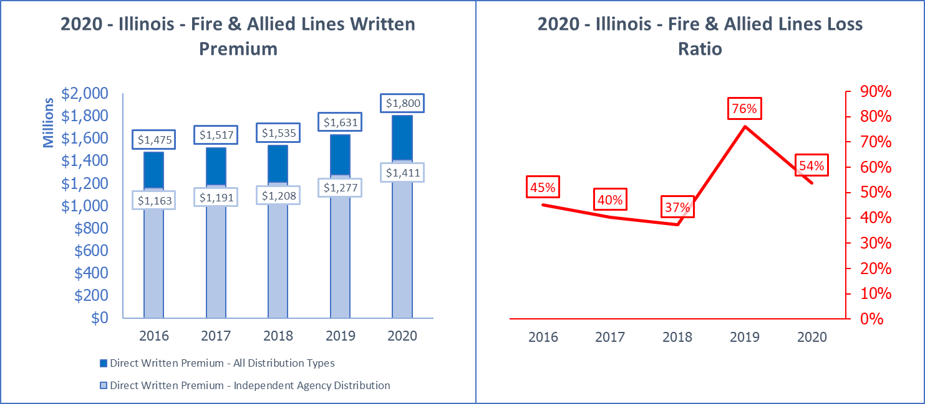
2020 - Illinois - Fire & Allied Lines Average Penetration: 78.5%
All Distribution Trend (DPW) | Ind. Agent Trend (DPW) | 5 yr. Loss Adj. Ratio | 5 yr. Combined Ratio | Domestic Surplus Lines ÷ ALL DPW
5.1% | 5.0% | 51% | 78% | 15.43%
Active Groups |Pol. Issuing | S.L. | RRGs => | Groups: 113 | Affil+Unaffil: 425 | S.L. Insurers: 89 | RRGs: 0
Top 5 Groups or Unaffil. [Mkt Share%] | 2020 DPW | 2020 Adj. Loss Ratio | 2020 Commission | Group Name or ALL L.O.B. DPW
Zurich Insurance US PC Group (G) [9.5%] | $170,387,000 | 76% | N/A | $552,156,000
Great American P & C Ins Grp (G) [8.5%] | $152,854,000 | 37% | N/A | $364,899,000
Sompo Holdings US Group (G) [8.3%] | $149,878,000 | 41% | N/A | $273,463,000
American International Group (G) [7.6%] | $136,833,000 | 44% | N/A | $534,272,000
FM Global Group (G) [5.6%] | $100,774,000 | 43% | N/A | $163,531,000
L.O.B. Total or Industry Ave. | $1,800,376,000 | 54% | 10.3% | $27,117,046,000
Top 10 IA Insurers
Great American Insurance Company | $141,721,000 | 36.4% | 15.6% | Great American P & C Ins Grp
Farmers Mutual Hail Insurance Co of Iowa | $52,833,000 | 22.8% | 16.1% | FMH Ins Grp
NAU Country Insurance Company | $48,571,000 | 30.2% | 16.2% | QBE North America Ins Grp
Producers Agriculture Insurance Company | $40,108,000 | 59.0% | 18.7% | Tokio Marine US PC Group
Foremost Insurance Co Grand Rapids, MI | $37,933,000 | 72.3% | 16.2% | Farmers Ins Grp
Zurich American Insurance Company | $37,851,000 | 60.6% | 5.5% | Zurich Insurance US PC Group
Travelers Indemnity Company | $36,391,000 | 39.8% | 9.1% | Travelers Group
Allianz Global Risks US Insurance Co | $35,462,000 | 12.6% | 2.7% | Allianz US PC Ins Cos
West Bend Mutual Insurance Company | $30,915,000 | 73.6% | 20.0% | ...
Endurance American Specialty Ins Co | $26,465,000 | 34.7% | 8.0% | Sompo Holdings US Group
Top 3 MGA/Wholesale Insurers
Rural Community Insurance Company | $105,835,000 | 78.0% | 8.0% | Zurich Insurance US PC Group
Stratford Insurance Company | $82,731,000 | 56.8% | 3.4% | American International Group
FMH Ag Risk Insurance Company | $11,264,000 | 26.1% | 15.5% | FMH Ins Grp
Top 3 Captive-Exclusive and Direct Insurers
COUNTRY Mutual Insurance Company | $93,172,000 | 37.3% | 4.4% | COUNTRY Financial Propy Cas Grp
State Farm Fire and Casualty Company | $27,810,000 | 3.1% | 12.6% | State Farm Group
Standard Guaranty Insurance Company | $27,083,000 | 34.3% | 2.6% | Assurant P&C Group
Top 3 Surplus Lines Insurers
Endurance American Specialty Ins Co | $26,465,000 | 34.7% | 8.0% | Sompo Holdings US Group
National Fire & Marine Insurance Co | $25,112,000 | 22.7% | 5.8% | Berkshire Hathaway Ins Grp
Lexington Insurance Company | $21,455,000 | 12.5% | 12.4% | American International Group
Top RRG
None in L.O.B. | #N/A | #N/A | #N/A | #N/A
Source: © A.M. Best Company — used by permission.
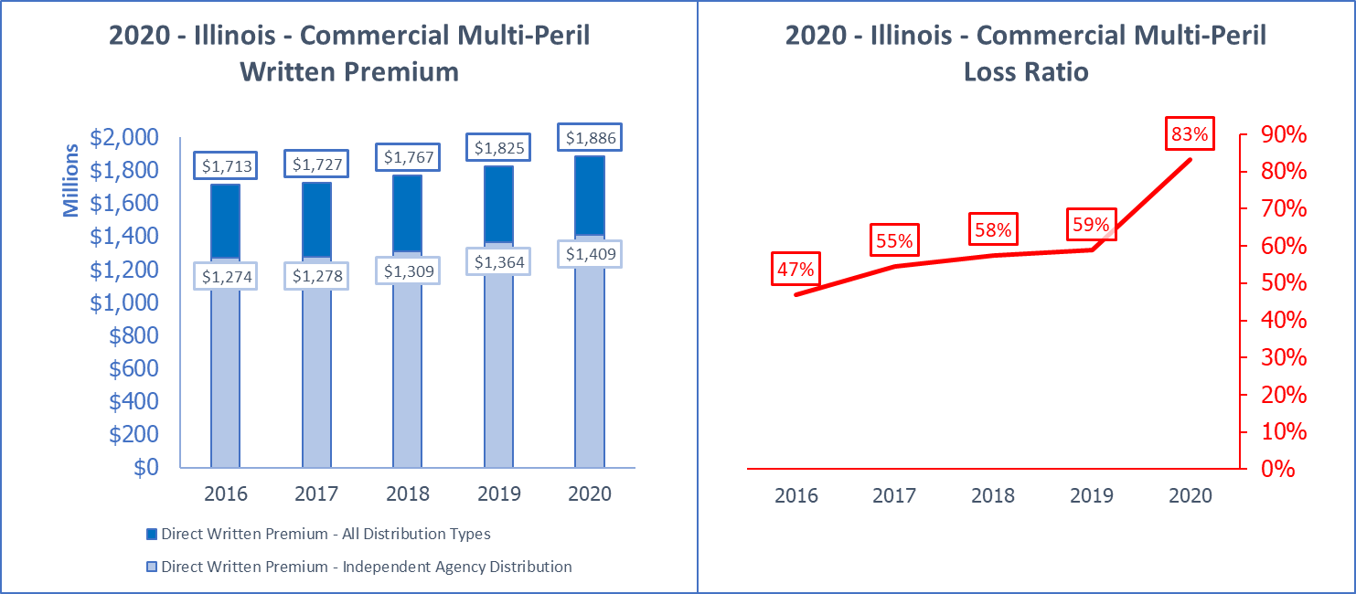
2020 - Illinois - Commercial Multi-Peril Average Penetration: 74.4%
All Distribution Trend (DPW) | Ind. Agent Trend (DPW) | 5 yr. Loss Adj. Ratio | 5 yr. Combined Ratio | Domestic Surplus Lines ÷ ALL DPW
2.4% | 2.6% | 61% | 101% | 3.52%
Active Groups |Pol. Issuing | S.L. | RRGs => | Groups: 99 | Affil+Unaffil: 371 | S.L. Insurers: 71 | RRGs: 0
Top 5 Groups or Unaffil. [Mkt Share%] | 2020 DPW | 2020 Adj. Loss Ratio | 2020 Commission | Group Name or ALL L.O.B. DPW
Travelers Group (G) [9.9%] | $187,243,000 | 77% | N/A | $1,206,490,000
State Farm Group (G) [6.5%] | $121,660,000 | 116% | N/A | $3,880,975,000
Chubb INA Group (G) [5.1%] | $96,994,000 | 61% | N/A | $967,156,000
Hartford Ins Grp (G) [4.2%] | $78,604,000 | 93% | N/A | $538,997,000
COUNTRY Financial Prop Cas Grp (G) [3.8%] | $72,328,000 | 65% | N/A | $1,292,753,000
L.O.B. Total or Industry Ave. | $1,885,770,000 | 83% | 16.2% | $27,117,046,000
Top 10 IA Insurers
Pekin Insurance Company | $65,035,000 | 60.9% | 18.9% | Pekin Ins Grp
Cincinnati Insurance Company | $52,581,000 | 59.2% | 18.9% | The Cincinnati Ins Cos
Erie Insurance Exchange | $47,290,000 | 64.2% | 18.9% | Erie Ins Grp
Federal Insurance Company | $45,182,000 | 44.3% | 13.3% | Chubb INA Group
Charter Oak Fire Insurance Company | $44,621,000 | 52.1% | 17.3% | Travelers Group
Philadelphia Indemnity Insurance Company | $41,436,000 | 83.3% | 15.0% | Tokio Marine US PC Group
Travelers Casualty Ins Co of America | $39,016,000 | 71.1% | 17.8% | Travelers Group
Ohio Security Insurance Company | $36,902,000 | 110.5% | 15.9% | Liberty Mutual Ins Cos
Citizens Insurance Company of America | $35,579,000 | 86.6% | 17.2% | Hanover Ins Group Prop & Cas Cos
Greater New York Mutual Insurance Co | $35,355,000 | 30.8% | 16.3% | Greater New York Group
Top 3 MGA/Wholesale Insurers
Specialty Risk of America | $7,675,000 | 45.6% | 21.1% | ...
State National Insurance Company, Inc. | $7,467,000 | 8.5% | 17.9% | Markel Corporation Group
Markel Insurance Company | $5,155,000 | 192.3% | 22.4% | Markel Corporation Group
Top 3 Captive-Exclusive and Direct Insurers
State Farm Fire and Casualty Company | $121,660,000 | 115.7% | 11.7% | State Farm Group
COUNTRY Mutual Insurance Company | $72,058,000 | 65.0% | 11.4% | COUNTRY Financial Propy Cas Grp
Allstate Indemnity Company | $30,892,000 | 67.2% | 11.4% | Allstate Ins Grp
Top 3 Surplus Lines Insurers
Agent Alliance Insurance Company | $9,513,000 | 23.7% | 1.8% | Allstate Ins Grp
Scottsdale Insurance Company | $8,079,000 | 80.5% | 21.3% | Nationwide Group
Ironshore Specialty Insurance Co | $5,837,000 | 28.5% | 8.2% | Liberty Mutual Ins Cos
Top RRG
None in L.O.B. | #N/A | #N/A | #N/A | #N/A
Source: © A.M. Best Company — used by permission.
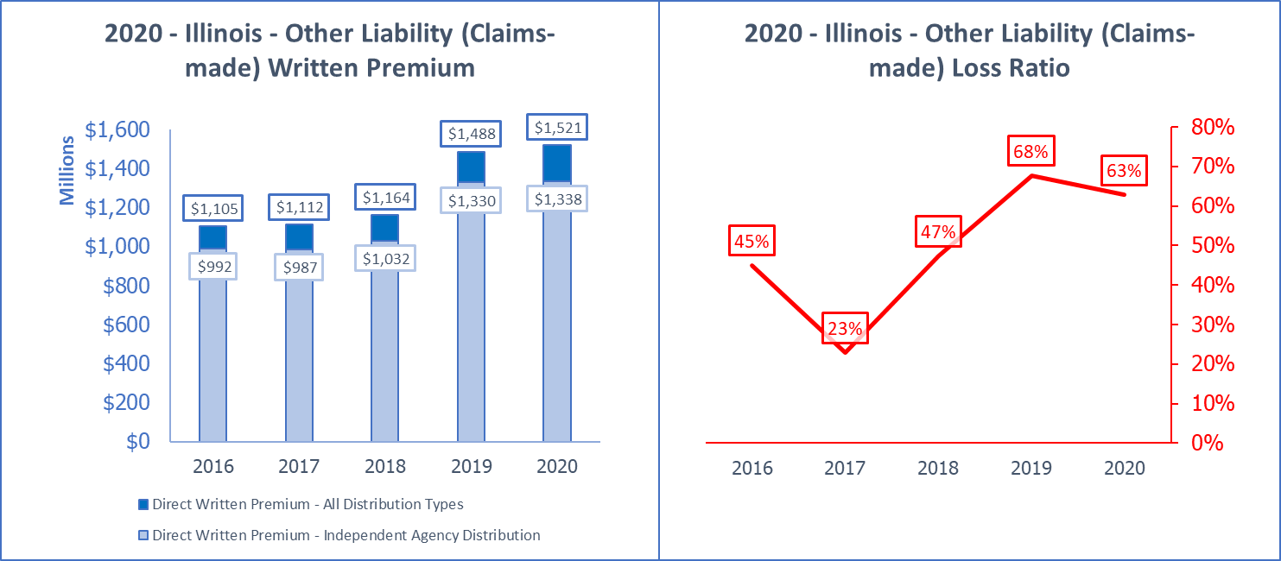
2020 - Illinois - Other Liability (Claims-made) Average Penetration: 88.9%
All Distribution Trend (DPW) | Ind. Agent Trend (DPW) | 5 yr. Loss Adj. Ratio | 5 yr. Combined Ratio | Domestic Surplus Lines ÷ ALL DPW
8.3% | 7.8% | 51% | 91% | 27.20%
Active Groups |Pol. Issuing | S.L. | RRGs => | Groups: 89 | Affil+Unaffil: 340 | S.L. Insurers: 90 | RRGs: 31
Top 5 Groups or Unaffil. [Mkt Share%] | 2020 DPW | 2020 Adj. Loss Ratio | 2020 Commission | Group Name or ALL L.O.B. DPW
Chubb INA Group (G) [9.7%] | $146,813,000 | 21% | N/A | $967,156,000
American International Group (G) [6.8%] | $103,762,000 | 111% | N/A | $534,272,000
CNA Ins Cos (G) [6.6%] | $101,124,000 | 45% | N/A | $632,876,000
XL Reinsurance America Group (G) [6.2%] | $94,162,000 | 83% | N/A | $230,579,000
Travelers Group (G) [5.3%] | $79,956,000 | 103% | N/A | $1,206,490,000
L.O.B. Total or Industry Ave. | $1,520,853,000 | 63% | 14.3% | $27,117,046,000
Top 10 IA Insurers
Continental Casualty Company | $79,387,000 | 42.7% | 16.5% | CNA Ins Cos
Federal Insurance Company | $75,256,000 | 25.2% | 13.5% | Chubb INA Group
Travelers Casualty and Surety Co of Amer | $65,886,000 | 98.2% | 14.1% | Travelers Group
Underwriters at Lloyd's, London (IL) | $57,351,000 | -4.1% | 17.9% | ...
XL Specialty Insurance Company | $55,696,000 | 96.0% | 9.2% | XL Reinsurance America Group
Illinois National Insurance Co. | $39,333,000 | 62.9% | 10.0% | American International Group
ACE American Insurance Company | $37,518,000 | 0.1% | 9.8% | Chubb INA Group
Allianz Global Risks US Insurance Co | $35,853,000 | 85.6% | 6.4% | Allianz US PC Ins Cos
Zurich American Insurance Company | $33,183,000 | 80.2% | 10.5% | Zurich Insurance US PC Group
AXIS Insurance Company | $32,350,000 | 85.5% | 14.3% | AXIS US Operations
Top 3 MGA/Wholesale Insurers
Evanston Insurance Company | $15,243,000 | 8.4% | 16.2% | Markel Corporation Group
U.S. Specialty Insurance Company | $15,232,000 | 149.4% | 20.3% | Tokio Marine US PC Group
TDC Specialty Insurance Company | $8,786,000 | 45.0% | 10.8% | Doctors Company Ins Grp
Top 3 Captive-Exclusive and Direct Insurers
Illinois State Bar Assn Mut Ins Co | $20,945,000 | 12.2% | 0.0% | ...
Liberty Surplus Insurance Corporation | $15,472,000 | 74.0% | 15.3% | Liberty Mutual Ins Cos
Ironshore Indemnity Inc. | $10,511,000 | 42.7% | 13.9% | Liberty Mutual Ins Cos
Top 3 Surplus Lines Insurers
Indian Harbor Insurance Company | $29,495,000 | 66.1% | 13.5% | XL Reinsurance America Group
National Fire & Marine Insurance Co | $24,621,000 | 36.0% | 15.9% | Berkshire Hathaway Ins Grp
Lexington Insurance Company | $23,749,000 | 203.5% | 10.9% | American International Group
Top RRG
Attorneys' Liab Assr Society Ltd., A RRG | $27,907,000 | 3.8% | 0.0% | ...
Source: © A.M. Best Company — used by permission.
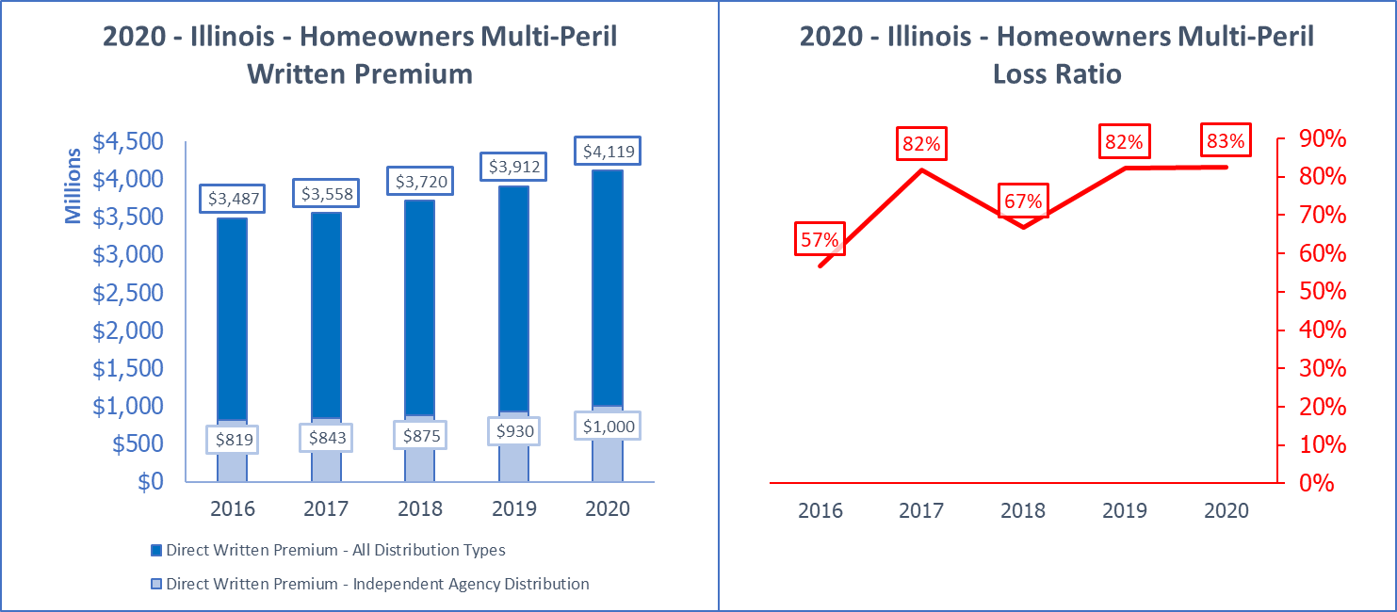
2020 - Illinois - Homeowners Multi-Peril Average Penetration: 23.7%
All Distribution Trend (DPW) | Ind. Agent Trend (DPW) | 5 yr. Loss Adj. Ratio | 5 yr. Combined Ratio | Domestic Surplus Lines ÷ ALL DPW
4.3% | 5.1% | 74% | 105% | 1.34%
Active Groups |Pol. Issuing | S.L. | RRGs => | Groups: 77 | Affil+Unaffil: 196 | S.L. Insurers: 14 | RRGs: 0
Top 5 Groups or Unaffil. [Mkt Share%] | 2020 DPW | 2020 Adj. Loss Ratio | 2020 Commission | Group Name or ALL L.O.B. DPW
State Farm Group (G) [32.9%] | $1,354,539,000 | 90% | N/A | $3,880,975,000
Allstate Ins Grp (G) [13.0%] | $535,691,000 | 76% | N/A | $1,745,216,000
COUNTRY Financial Prop Cas Grp (G) [8.2%] | $338,308,000 | 80% | N/A | $1,292,753,000
American Family Ins Grp (G) [5.9%] | $244,559,000 | 73% | N/A | $624,469,000
Farmers Ins Grp (G) [5.1%] | $212,092,000 | 88% | N/A | $611,574,000
L.O.B. Total or Industry Ave. | $4,118,834,000 | 83% | 12.1% | $27,117,046,000
Top 10 IA Insurers
Allstate Vehicle and Property Ins Co | $257,850,000 | 85.0% | 11.1% | Allstate Ins Grp
TravCo Insurance Company | $85,743,000 | 92.2% | 16.1% | Travelers Group
Auto-Owners Insurance Company | $69,448,000 | 80.1% | 19.5% | Auto-Owners Ins Grp
Travelers Home and Marine Ins Co | $66,525,000 | 90.0% | 15.6% | Travelers Group
Erie Insurance Company | $60,108,000 | 91.1% | 16.5% | Erie Ins Grp
Safeco Insurance Company of Illinois | $50,854,000 | 65.0% | 13.5% | Liberty Mutual Ins Cos
Farmers Automobile Insurance Assn | $47,264,000 | 86.8% | 14.2% | Pekin Ins Grp
Citizens Insurance Company of Illinois | $38,382,000 | 86.8% | 15.4% | Hanover Ins Group Prop & Cas Cos
Chubb National Insurance Company | $30,122,000 | 85.3% | 17.0% | Chubb INA Group
West Bend Mutual Insurance Company | $26,941,000 | 98.1% | 15.6% | ...
Top 3 MGA/Wholesale Insurers
Liberty Mutual Personal Insurance Co | $90,665,000 | 73.6% | 4.3% | Liberty Mutual Ins Cos
Spinnaker Insurance Company | $11,150,000 | 120.4% | 13.5% | ...
Lemonade Insurance Company | $9,041,000 | 47.2% | 0.4% | ...
Top 3 Captive-Exclusive and Direct Insurers
State Farm Fire and Casualty Company | $1,354,539,000 | 89.8% | 11.7% | State Farm Group
COUNTRY Mutual Insurance Company | $334,403,000 | 80.0% | 12.9% | COUNTRY Financial Propy Cas Grp
Farmers Insurance Exchange | $154,109,000 | 97.3% | 13.0% | Farmers Ins Grp
Top 3 Surplus Lines Insurers
Homesite Insurance Company of Florida | $47,790,000 | 68.6% | 13.9% | American Family Ins Grp
Chubb Custom Insurance Company | $3,973,000 | 13.4% | 16.2% | Chubb INA Group
Scottsdale Insurance Company | $1,568,000 | 57.0% | 23.4% | Nationwide Group
Top RRG
None in L.O.B. | #N/A | #N/A | #N/A | #N/A
Source: © A.M. Best Company — used by permission.
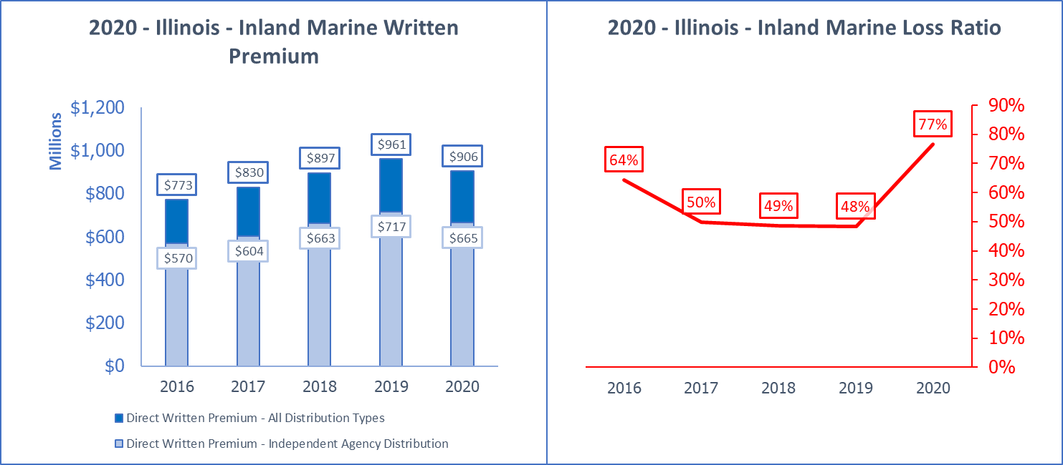
2020 - Illinois - Inland Marine Average Penetration: 73.7%
All Distribution Trend (DPW) | Ind. Agent Trend (DPW) | 5 yr. Loss Adj. Ratio | 5 yr. Combined Ratio | Domestic Surplus Lines ÷ ALL DPW
4.1% | 3.9% | 57% | 90% | 6.08%
Active Groups |Pol. Issuing | S.L. | RRGs => | Groups: 113 | Affil+Unaffil: 409 | S.L. Insurers: 63 | RRGs: 0
Top 5 Groups or Unaffil. [Mkt Share%] | 2020 DPW | 2020 Adj. Loss Ratio | 2020 Commission | Group Name or ALL L.O.B. DPW
CNA Ins Cos (G) [14.7%] | $133,473,000 | 54% | N/A | $632,876,000
Liberty Mutual Ins Cos (G) [13.0%] | $118,089,000 | 63% | N/A | $1,019,564,000
Chubb INA Group (G) [6.3%] | $57,333,000 | 56% | N/A | $967,156,000
Travelers Group (G) [5.1%] | $45,792,000 | 138% | N/A | $1,206,490,000
State Farm Group (G) [5.1%] | $45,778,000 | 46% | N/A | $3,880,975,000
L.O.B. Total or Industry Ave. | $906,327,000 | 77% | 15.0% | $27,117,046,000
Top 10 IA Insurers
Continental Casualty Company | $131,444,000 | 54.1% | 13.5% | CNA Ins Cos
Travelers Property Casualty Co of Amer | $29,211,000 | 193.2% | 17.2% | Travelers Group
National Casualty Company | $26,567,000 | 69.3% | 28.4% | Nationwide Group
American Bankers Insurance Co of Florida | $20,319,000 | 48.8% | 12.7% | Assurant P&C Group
Lexington Insurance Company | $17,600,000 | 6.7% | 14.8% | American International Group
ACE American Insurance Company | $16,030,000 | 107.5% | 13.9% | Chubb INA Group
Zurich American Insurance Company | $14,870,000 | 20.1% | 37.9% | Zurich Insurance US PC Group
AGCS Marine Insurance Company | $14,657,000 | 67.7% | 18.2% | Allianz US PC Ins Cos
Artisan and Truckers Casualty Company | $11,210,000 | 40.7% | 9.3% | Progressive Ins Grp
New Hampshire Insurance Company | $11,155,000 | 4.6% | 15.5% | American International Group
Top 3 MGA/Wholesale Insurers
American Pet Insurance Company | $11,320,000 | 61.9% | 2.8% | ...
Securian Casualty Company | $9,834,000 | 40.6% | 51.2% | ...
Houston Specialty Insurance Company | $8,610,000 | 77.3% | 20.9% | Skyward Specialty Ins Grp
Top 3 Captive-Exclusive and Direct Insurers
Liberty Insurance Underwriters, Inc. | $109,099,000 | 64.3% | 0.0% | Liberty Mutual Ins Cos
State Farm Fire and Casualty Company | $45,778,000 | 45.6% | 11.7% | State Farm Group
COUNTRY Mutual Insurance Company | $11,091,000 | 21.6% | 4.1% | COUNTRY Financial Propy Cas Grp
Top 3 Surplus Lines Insurers
Lexington Insurance Company | $17,600,000 | 6.7% | 14.8% | American International Group
Houston Specialty Insurance Company | $8,610,000 | 77.3% | 20.9% | Skyward Specialty Ins Grp
Evanston Insurance Company | $3,983,000 | 69.6% | 15.9% | Markel Corporation Group
Top RRG
None in L.O.B. | #N/A | #N/A | #N/A | #N/A
Source: © A.M. Best Company — used by permission.
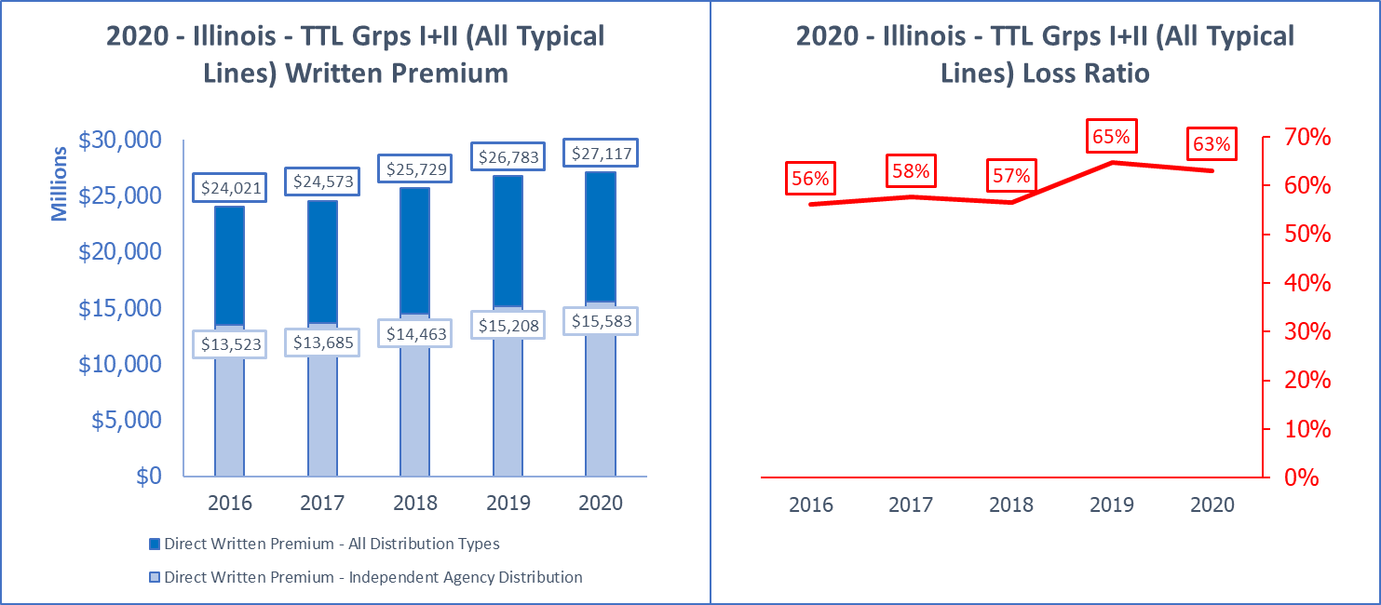
2020 - Illinois - TTL Grps I+II (All Typical Lines) Average Penetration: 56.5%
All Distribution Trend (DPW) | Ind. Agent Trend (DPW) | 5 yr. Loss Adj. Ratio | 5 yr. Combined Ratio | Domestic Surplus Lines ÷ ALL DPW
3.1% | 3.6% | 60% | 92% | 6.19%
Active Groups |Pol. Issuing | S.L. | RRGs => | Groups: 201 | Affil+Unaffil: 980 | S.L. Insurers: 133 | RRGs: 80
Top 5 Groups or Unaffil. [Mkt Share%] | 2020 DPW | 2020 Adj. Loss Ratio | 2020 Commission | Group Name or ALL L.O.B. DPW
State Farm Group (G) [14.3%] | $3,880,975,000 | 69% | N/A | $3,880,975,000
Allstate Ins Grp (G) [6.4%] | $1,745,216,000 | 57% | N/A | $1,745,216,000
COUNTRY Financial Prop Cas Grp (G) [4.8%] | $1,292,753,000 | 63% | N/A | $1,292,753,000
Travelers Group (G) [4.4%] | $1,206,490,000 | 68% | N/A | $1,206,490,000
Liberty Mutual Ins Cos (G) [3.8%] | $1,019,564,000 | 65% | N/A | $1,019,564,000
L.O.B. Total or Industry Ave. | $27,117,057,000 | 63% | 11.5% | $27,117,046,000
Top 10 IA Insurers
Continental Casualty Company | $326,115,000 | 75.4% | 12.0% | CNA Ins Cos
Progressive Northern Insurance Company | $302,221,000 | 54.2% | 10.6% | Progressive Ins Grp
Zurich American Insurance Company | $272,218,000 | 56.7% | 7.6% | Zurich Insurance US PC Group
Allstate Vehicle and Property Ins Co | $261,739,000 | 83.9% | 11.1% | Allstate Ins Grp
West Bend Mutual Insurance Company | $247,507,000 | 61.1% | 16.2% | ...
Travelers Property Casualty Co of Amer | $244,216,000 | 80.2% | 12.4% | Travelers Group
Federal Insurance Company | $230,115,000 | 36.5% | 14.3% | Chubb INA Group
Cincinnati Insurance Company | $221,610,000 | 54.7% | 18.5% | The Cincinnati Ins Cos
Erie Insurance Exchange | $210,299,000 | 62.6% | 13.6% | Erie Ins Grp
Great American Insurance Company | $200,444,000 | 38.4% | 15.4% | Great American P & C Ins Grp
Top 3 MGA/Wholesale Insurers
Liberty Mutual Personal Insurance Co | $169,260,000 | 74.4% | 2.6% | Liberty Mutual Ins Cos
Rural Community Insurance Company | $105,835,000 | 78.0% | 8.0% | Zurich Insurance US PC Group
Stratford Insurance Company | $84,285,000 | 56.0% | 3.6% | American International Group
Top 3 Captive-Exclusive and Direct Insurers
State Farm Mutual Automobile Ins Co | $2,139,572,000 | 56.4% | 9.6% | State Farm Group
State Farm Fire and Casualty Company | $1,741,404,000 | 85.2% | 11.6% | State Farm Group
COUNTRY Mutual Insurance Company | $910,465,000 | 65.7% | 10.6% | COUNTRY Financial Propy Cas Grp
Top 3 Surplus Lines Insurers
National Fire & Marine Insurance Co | $121,130,000 | 55.1% | 14.2% | Berkshire Hathaway Ins Grp
Lexington Insurance Company | $92,074,000 | 67.2% | 11.9% | American International Group
Evanston Insurance Company | $66,819,000 | 43.5% | 17.2% | Markel Corporation Group
Top RRG
Attorneys' Liab Assr Society Ltd., A RRG | $27,907,000 | 3.8% | 0.0% | ...
Source: © A.M. Best Company — used by permission.

Illinois Penetration: Top L.O.B.s
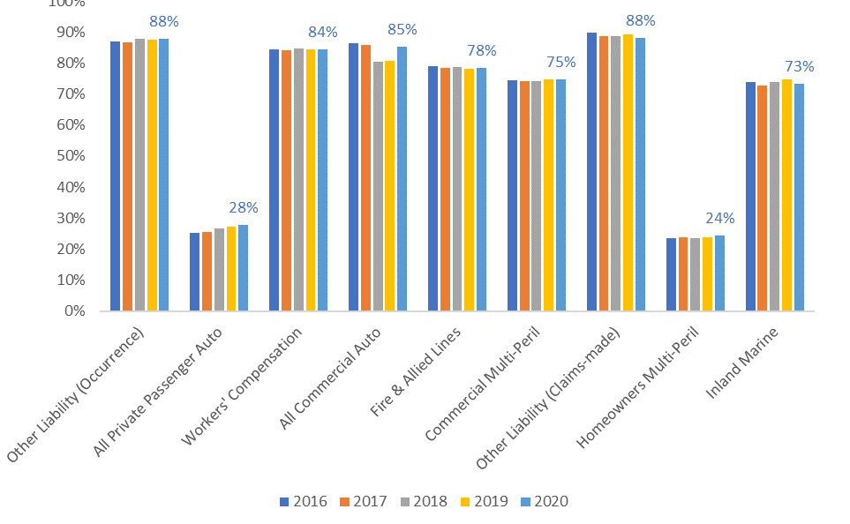
Source: © A.M. Best Company — used by permission.
Notes or Comments: This graph shows independent agent distribution as a percentage of all distribution of P-C premiums by major L.O.B. This measure is attained by dividing the total direct written premiums for each line of business written by insurers that use independent agents by the total of all premiums for all insurers in that line of business. The figures above are based on premiums reported by A.M. Best in their standard industry reports for each L.O.B.

Illinois Average Commissions: Top L.O.B.s
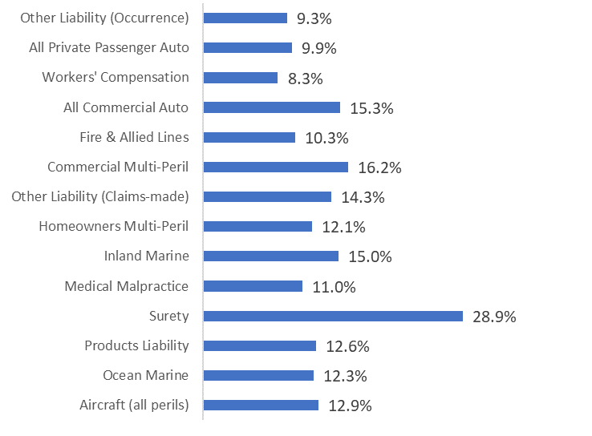
Source: © A.M. Best Company — used by permission.
Notes or Comments: Commission Rates are calculated based on a page in insurer Yellow Books called “Exhibit of Premiums and Losses (Statutory Page 14)." This is part of the annual filing and insurers break-out all L.O.B.s by state and provide 12 columns of data on each L.O.B. Along with direct premiums written, direct premiums earned and direct incurred losses, also provided is commissions and brokerage expenses. By dividing commissions and brokerage expenses by direct premiums written for each of the above L.O.B.s, the average commission paid in Illinois is obtained. The insurer annual report instructions tell insurers to include contingent commissions. The lines shown above are the top lines of business in Illinois as written by independent agents but they are the average commission rate paid to all distribution types.

Illinois Surplus Lines
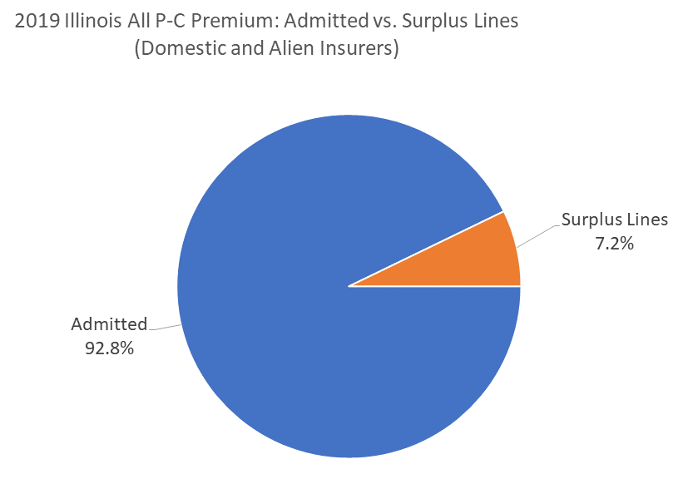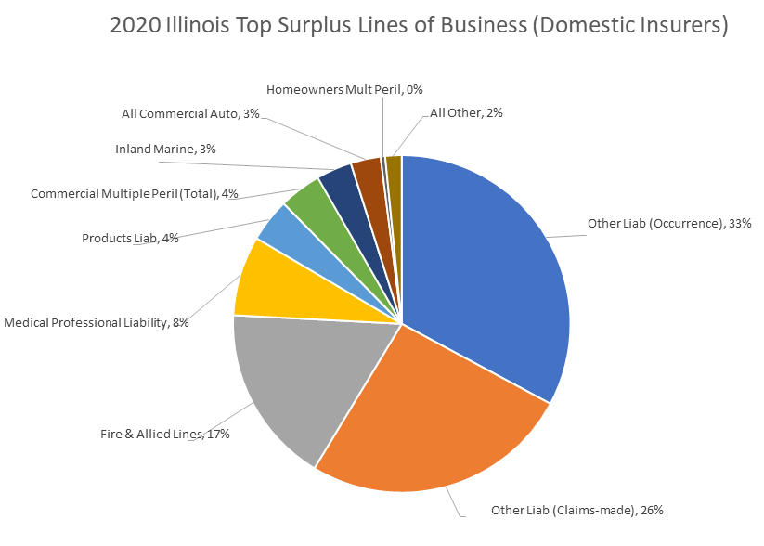
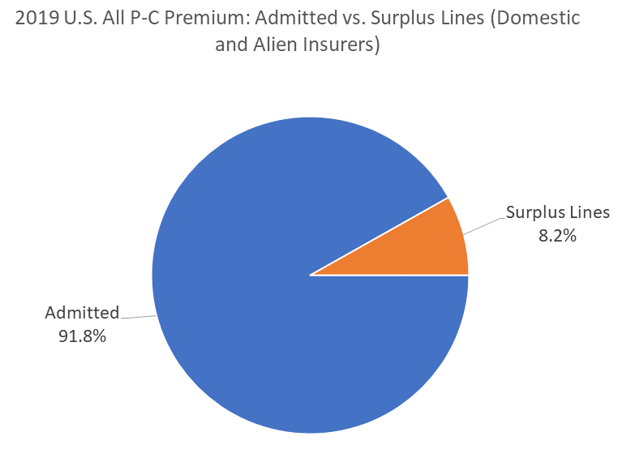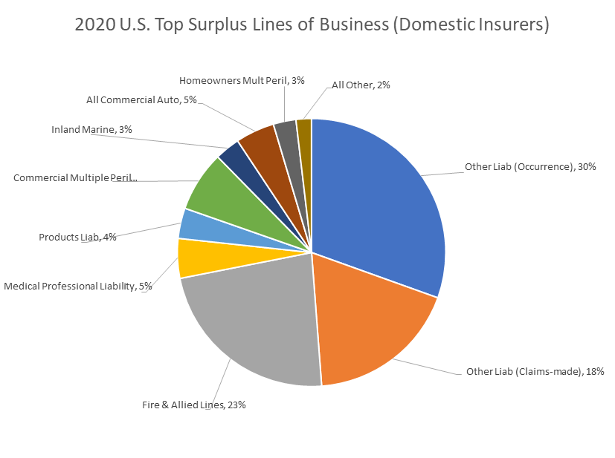

Source: © A.M. Best Company — used by permission and National Association of Ins Commissions Surplus Lines Industry Summary
Notes or Comments: The U.S. has an average of 8.2% of all its P-C premiums written in surplus lines. Illinois’s utilization of surplus lines is lower than that at 6.1% of all P-C premiums. Surplus lines is also commonly referred to as non-admitted, "E&S" or excess and surplus lines. It is important to note the data used for most of this P-C marketplace summary DOES NOT include alien surplus lines premiums in totals or otherwise, only insurers that are domestic surplus lines insurers are in most summaries. The right-hand pie chart is a good example of this. Those breakouts are based exclusively on domestic surplus line insurers (for example, Lexington Ins Co). That is because, when domestic insurers file their "yellow book" and Statutory Page 14, it is the same as admitted insurers. As alien surplus lines insurers do not file those same annual reports, alien data cannot be included the line of business breakout pie chart (for example, Lloyds of London).
Note: The left-hand chart data estimating all distribution of Surplus Lines (including alien insurers) is 2019 data as it depends on a reporting process at the NAIC that is completed later in the calendar year.

Illinois Fire & Allied Lines Breakout
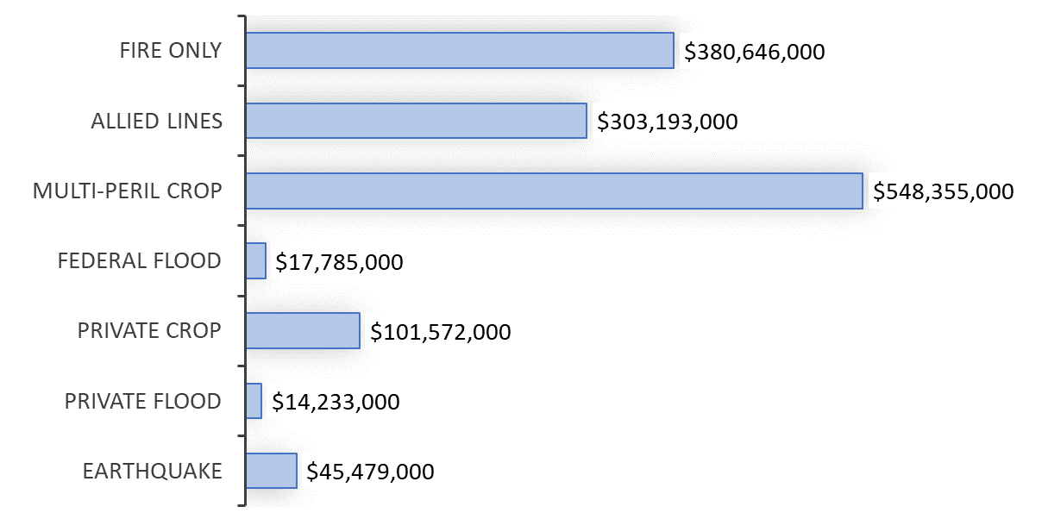
2020 - Illinois Fire and Allied Lines Component L.O.B.s (IA-Only Data)
Line of Business | Ind. Agent - DPW | All Distribution-DPW | Agent Distribution
Fire Only | $380,646,000 | $494,777,000 | 77%
Allied Lines | $303,193,000 | $429,973,000 | 71%
Multi-Peril Crop | $548,355,000 | $625,714,000 | 88%
Federal Flood | $17,785,000 | $27,602,000 | 64%
Private Crop | $101,572,000 | $118,421,000 | 86%
Private Flood | $14,233,000 | $19,865,000 | 72%
Earthquake | $45,479,000 | $84,023,000 | 54%
Largest Sub-Line: Top Independent Agent Policy-Issuing Insurers (2020) -Multi-Peril Crop
Insurer Name | DPW-This LOB | Commission Paid | Insurer Group ("…" is No Group)
Great American Insurance Company | $124,000,000 | 15.0% | Great American P & C Ins Grp
NAU Country Insurance Company | $42,321,000 | 15.5% | QBE North America Ins Grp
Farmers Mutual Hail Insurance Co of Iowa | $41,694,000 | 15.8% | FMH Ins Grp
Producers Agriculture Insurance Company | $34,461,000 | 18.9% | Tokio Marine US PC Group
ACE Property and Casualty Insurance Co | $20,781,000 | 1.8% | Chubb INA Group
Source: © A.M. Best Company — used by permission
Notes or Comments: This breakout is provided to give more detail of a large combination line of business: Fire & Allied Lines. The importance of this L.O.B. to independent agents varies from state to state. The premiums shown in the graph are those for independent agents but the table below shows all premiums for each L.O.B. Generally, Fire & Allied lines is a major L.O.B. where crop insurance is prevalent. Flood insurance writings, also, vary widely between states as does Earthquake.

Illinois Dividends and Lines of Business
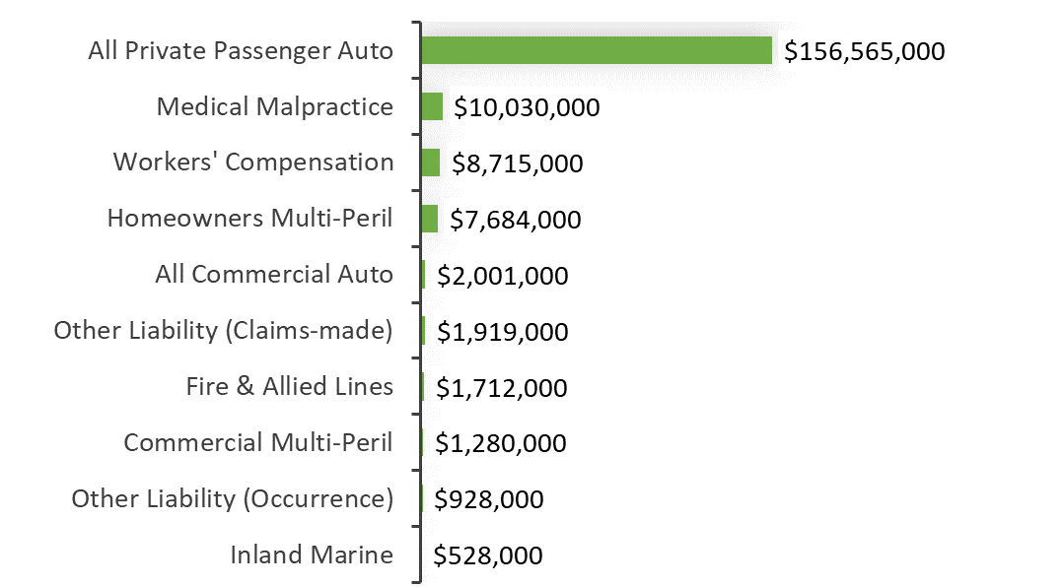
2020 Illinois Top Ten Lines of Business Paying Policy Dividends
Line of Business | Dividends Paid | Average Dividend Rate | Insurers Paying Some Dividends
All Private Passenger Auto | $156,565,000 | 6.3% | 5.6%
Medical Malpractice | $10,030,000 | 5.5% | 11.1%
Workers' Compensation | $8,715,000 | 1.0% | 22.9%
Homeowners Multi-Peril | $7,684,000 | 10.8% | 2.0%
All Commercial Auto | $2,001,000 | 1.7% | 3.8%
Other Liability (Claims-made) | $1,919,000 | 7.7% | 2.4%
Fire & Allied Lines | $1,712,000 | 1.6% | 2.4%
Commercial Multi-Peril | $1,280,000 | 0.7% | 3.8%
Other Liability (Occurrence) | $928,000 | 5.1% | 2.1%
Inland Marine | $528,000 | 8.8% | 1.2%
2020 Illinois All Private Passenger Auto Top Dividend Paying Insurers
Insurer Name | DPW-#1 LOB Shown Above | Insurer Div. Rate | Insurer Group ("…" is No Group)
State Farm Mutual Automobile Ins Co | $2,121,983,000 | 5.7% | State Farm Group
United Services Automobile Association | $70,873,000 | 20.0% | USAA Group
USAA Casualty Insurance Company | $68,434,000 | 10.1% | USAA Group
Erie Insurance Exchange | $96,155,000 | 5.1% | Erie Ins Grp
USAA General Indemnity Company | $51,217,000 | 6.7% | USAA Group
Amica Mutual Insurance Company | $12,885,000 | 18.0% | Amica Mutual Group
Garrison Property and Casualty Ins Co | $22,275,000 | 6.4% | USAA Group
West Bend Mutual Insurance Company | $37,306,000 | 3.0% | ...
American Select Insurance Company | $10,845,000 | 3.8% | Westfield Group
Westfield National Insurance Company | $2,971,000 | 3.9% | Westfield Group
Source: © A.M. Best Company — used by permission
Notes or Comments: This breakout shows the impact of dividends paid on some L.O.B.s. Dividend-paying lines of business are usually led by Workers’ Compensation, but other lines pay dividends as well. In 2020, personal auto dividends increased dramatically. The percentage of insurers in Illinois that pay dividends on at least some policies is shown for each L.O.B.

Appendix: Data for Independent Agents
The source of most of the data presented in this summary is A.M. Best and its Financial Suite. That is a system that allows various standard and custom reports. A.M. Best obtains the data from the annual statements filed by each domestic Ins Co with its state regulator. This summary takes standard reports, classifications and calculations made available by A.M. Best and adds custom data extractions from their systems to arrive at what is intended to be an insurance agent’s perspective on data from insurer annual reports.
You may be familiar with the term "Yellow Book" for the annual statement required to be made by P-C insurers with their primary regulator. That is, the original source of most of the data in this summary but A.M. Best makes organizing and presenting it in an agent-focused way possible. The reference to “Yellow Book” is based on history. Insurers in different insurance categories had a designated color for their annual reports—such as yellow for P-C or blue for life.
The data presentations are designed to be consistent with the member agent's view of the insurance world. That is, unlike industry watchers of insurer profitability and insolvency, direct written premiums are used in this P-C summary—not gross premiums or net written premiums. The latter is typically used by the industry press and industry analysts and those premiums can include reinsurance and inter-company transfers. While useful in the context of solvency or insurer profitability, net and gross premiums can cloud the picture of the independent agent’s experience in the marketplace.
Finally, take note that in presentations of industry data like this one, L.O.B.s are also often grouped by similar L.O.B.s as they are tracked as part of annual statements. The page in annual statements used most frequently in this summary is Statutory Page 14 which is also known as the “States Page.” As some L.O.B.s are overly specific (for example, automobile physical damage is separate from automobile liability), it is logical to combine some of these lines. In other cases, the individual lines are often so broad, they are then broken down further. Fire & Allied lines is a good example of that sort of standard L.O.B. combination. In all cases, the goal of this summary is to present the L.O.B. data to align as closely as possible with insurance agency operations, marketing strategies or staff assignments. If a combined L.O.B. represents important subsidiary L.O.B.s or another analysis of a more specific L.O.B. is needed it is broken out.

Appendix: NAIC Yellow Book Instructions and L.O.B. Definitions
The National Association of Ins Commissioners provides instructions to insurers for completing the annual statement (also known as Yellow Book). The below are taken from an appendix to the instructions for the last year in the data contained in this summary. When insurers classify premiums, losses, commissions, etc. on a line of business (L.O.B.) basis, the below are the definition that guide them. This most impactful with this summary with the data take from Statutory Page 14, also known as the “States Page.” That pages lists all 34 L.O.B.s and premiums, losses, commissions, etc. on a separate page for every U.S. state.
Line-of-Business (L.O.B. or Combination) | NAIC Line Numbers | Definition
Aggregate Write-ins | Line 34 | Explained coverage written in that do not fit elsewhere.
Aircraft (all perils) | Line 22 | Coverage for aircraft (hull) and their contents; aircraft owners’ and aircraft manufacturers’ liability to passengers, airports and other third parties.
All Commercial Auto | Lines 19.3+19.4+21.1 | Commercial Auto No-Fault (Personal Injury Protection). Other Commercial Auto Passenger Liability (Include-BI, PD, UM and UIM). Commercial Auto Physical Damage.
All Private Passenger | Lines 19.1+19.2+21.1 | Private Passenger Auto No-Fault (Personal Injury Protection). Other Private Passenger Auto Liability (Include-BI/PD/UM and UIM). Private Passenger Auto Physical Damage.
Boiler & Machinery | Line 27 | Coverage for the failure of boilers, machinery and electrical equipment. Benefits include: (i) property of the insured that has been directly damaged by the accident. (ii) Costs of temporary repairs and expediting expenses. (iii) Liability for damage to the property of others.
Burglary & Theft | Line 26 | Coverage for property taken or destroyed by breaking and entering the insured’s premises, burglary or theft, forgery or counterfeiting, fraud, kidnap and ransom, and off-premises exposure.
Commercial Multiple Peril | Line 5 | A contract for a commercial enterprise that packages two or more Ins Coverages protecting an enterprise from various property and liability risk exposures. Frequently includes fire, allied lines, various other coverages (e.g., difference in conditions) and liability coverage (such coverages would be included in other annual statement lines, if written individually). Include multi-peril policies (other than farmowners, homeowners and automobile policies) that include coverage for liability other than auto. (Builders’ Risk Policies, Businessowners, Commercial Package Policies, Manufacturers Output Policies, e-Commerce and Difference-in-Conditions).
Credit | Line 28 | Coverage purchased by consumers, manufacturers, merchants, educational institutions or other providers of goods and services extending credit, for indemnification of losses or damages resulting from the nonpayment of debts owed to/from them for goods or services provided in the normal course of their business.
Excess Workers’ Compensation | Line 17.3 | Indemnification coverage provided to self-insured employers on an excess of loss basis.
Farmowners Multiperil | Line 4 | A package policy for farming and ranching risks, similar to a homeowners policy, that has been adopted for farms and ranches and includes both property and liability coverages for personal and business losses. Coverages include farm dwellings and their contents, barns, stables, other farm structures and farm inland marine, such as mobile equipment and livestock. A commercial package policy for farming and ranching risks that includes both property and liability coverage. Coverage includes barns, stables, other farm structures and farm inland marine, such as mobile equipment and livestock.
Fidelity | Line 23 | A bond covering an employer’s loss resulting from an employee’s dishonest act (e.g., loss of cash, securities, valuables, etc.)
Financial Guaranty | Line 10 | A surety bond, insurance policy, or when issued by an insurer, an indemnity contract and any guaranty similar to the foregoing types, under which loss is payable upon proof of occurrence of financial loss to an insured claimant, obligee or indemnitee as a result of failure to perform a financial obligation (see Financial Guaranty Insurance Guideline (#1626)).
Fire & Allied Lines | Lines 1 + 2.1 + 2.2 + 2.3 + 12 | Fire, Allied Lines, Multi-Peril Crop, Federal Flood, Private Crop, Private Flood and Earthquake (see further descriptions of each under Fire & Allied Lines).
Homeowners Multiperil | Line 3 | A package policy combining broad property coverage for the personal property and/or structure with broad personal liability coverage. Coverage applicable to the dwelling, appurtenant structures, unscheduled personal property and additional living expense are typical. Includes mobile homes at a fixed location. (Alternative Workers’ Compensation, Employers’ Liability and Standard Workers’ Compensation).
Inland Marine | Line 9 | Coverage for property that may be in transit, held by a bailee, at a fixed location, a movable good that is often at different locations (e.g., off-road construction equipment) or scheduled property (e.g., Homeowners Personal Property Floater), including items such as live animals, property with antique or collector’s value, etc. This line also includes instrumentalities of transportation and communication, such as bridges, tunnels, piers, wharves, docks, pipelines, power and phone lines, and radio and television towers. (Animal Mortality, EDP Policies, Pet Insurance Plans, Communication Equipment, Event Cancellation, Travel Coverage, Vehicle Excess Waiver, Boatowners, Other Commercial Inland Marine, Other Personal Marine and Cash and Cash in Transit Insurance).
Medical Professional Liability | Line 11 | Insurance coverage protecting a licensed health care provider or health care facility against legal liability resulting from the death or injury of any person due to the insured’s misconduct, negligence, or incompetence in rendering professional services. Medical Professional Liability is also known as Medical Malpractice.
Mortgage Guaranty | Line 6 | Insurance that indemnifies a lender from loss if a borrower fails to meet required mortgage payments.
Ocean Marine | Line 8 | Coverage for ocean and inland water transportation exposures; goods or cargoes; ships or hulls; earnings; and liability.
Other Liability (Claims-made) | Line 17.2 | Same as 17.1 but on a Claims-Made Basis. These policies cover insured events that are reported (as defined in the policy) within the effective dates of the policy, subject to retroactive dates and extended reporting periods when applicable.
Other Liability (Occurrence) | Line 17.1 | Occurrence Based: These policies cover insured events that occur within the effective dates of the policy, regardless of when they are reported to the reporting entity. Ins Coverage protecting the insured against legal liability resulting from negligence, carelessness or a failure to act, causing property damage or personal injury to others. Typically, coverages include construction and alteration liability; contingent liability; contractual liability; elevators and escalators liability; errors and omissions liability, environmental pollution liability; excess stop loss, excess over insured or self-insured amounts and umbrella liability; liquor liability; personal injury liability; premises and operations liability; completed operations liability, nonmedical professional liability, etc. Also includes indemnification coverage provided to self-insured employers on an excess of loss basis (excess workers’ compensation). (Completed Operations, Construction Liability, Contingent Liability, Contractual Liability, Elevators, Error and Omissions, Environmental Pollution, Excess and Umbrella, Personal Liability, Premises and Operations, Excess Workers’ Compensation, Commercial General Liability, Comprehensive Personal Liability, Day Care Centers, Directors and Officers, Employee Benefit Liability, Employers’ Liability, Employment Practices, Fire Legal, Municipal Liability, Nuclear Energy, Veterinarian, Internet Liability and Cyber Liability). Excludes excess workers’ compensation.
Products Liability | Line 18 | Insurance coverage protecting the manufacturer, distributor, seller or lessor of a product against legal liability resulting from a defective condition causing personal injury, or damage, to any individual or entity, associated with the use of the product.
Surety | Line 24 | A three–party agreement where the insurer agrees to pay a second party (the obligee) or make complete an obligation in response to the default, acts or omissions of a third party (the principal).
Warranty | Line 30 | Coverage that protects against manufacturer’s defects past the normal warranty period and for repair after breakdown to return a product to its originally intended use. Warranty insurance generally protects consumers from financial loss caused by the seller’s failure to rectify or compensate for defective or incomplete work and cost of parts and labor necessary to restore a product’s usefulness. Includes, but is not limited to, coverage for all obligations and liabilities incurred by a service contract provider, mechanical breakdown insurance and service contracts written by insurers. (Mechanical Breakdown and Service Contracts).
Workers Compensation | Line 16 | Insurance that covers an employer’s liability for injuries, disability or death to persons in their employment, without regard to fault, as prescribed by state or Federal workers’ compensation laws and other statutes. Includes employer’s liability coverage against the common law liability for injuries to employees (as distinguished from the liability imposed by Workers’ Compensation Laws). Excludes excess workers’ compensation.

Fire & Allied Lines Breakout | NAIC Line Numbers | Definition
Fire Only | Line 1 | Coverage protecting the insured against the loss to real or personal property from damage caused by the peril of fire or lightning, including business interruption, loss of rents, etc.
Allied Lines | Line 2.1 | Extended coverage; glass; tornado, windstorm and hail; sprinkler and water damage; explosion, riot and civil commotion; rain; and damage from aircraft and vehicle.
Multi-Peril Crop | Line 2.2 | Insurance protection that is subsidized or reinsured by the Federal Crop Ins Corporation for protection against losses due to damage, decreases in revenues and/or gross margins from crop, livestock and other agricultural-related production from unfavorable weather conditions, drought, wind, frost, fire or lightning, flood, hail, insect infestation, disease or other yield-reducing conditions or perils.
Federal Flood | Line 2.3 | Coverage provided by the Federal Insurance Administration (FIA) of the Federal Emergency Management Agency (FEMA) through insurers participating in the National Flood Insurance Program’s (NFIP) Write Your Own (WYO) program. Coverage is subject to the terms and conditions provided in the Financial Assistance/Subsidy Arrangement between the reporting entity and the FIA.
Private Crop | Line 2.4 | Private market coverage for crop insurance and agricultural-related protection, such as hail and fire, and is not reinsured by the Federal Crop Ins
Private Flood | Line 2.5 | Private market coverage (primary standalone, first dollar policies that cover the flood peril and excess flood) for flood insurance that is not offered through the National Flood Insurance Program. (Sewer/water backup coverage issued as an endorsement homeowners or commercial policy.)
Earthquake | Line 12 | Property coverages for losses resulting from a sudden trembling or shaking of the earth, including that caused by volcanic eruption. Excluded are losses resulting from fire, explosion, flood or tidal wave following the covered event.
Source: ©1984 –2019 National Association of Ins Commissioners: Annual Statement Instructions Property/Casualty-2019 Reporting Year

Appendix: Insurer “Marketing Type”
Insurers submit a “Gallery Report” to A.M. Best and that includes the insurer’s designation of their “Marketing Type.” The possible Marketing Type classifications are shown below. Insurers can also report combinations of the below for a policy-issuing insurer. The five-year graphs, where independent agent distributions are shown, are based on A.M. Best determinations of premiums and distribution as shown in their standard industry reports for all insurers combined.
- Affinity Group Marketing
- Bank
- Broker
- Career Agent
- Direct Response
- Exclusive/Captive Agent
- General Agent
- Inactive
- Independent Agency
- Internet
- Managing General Agent
- Not Available
- Other
- Other Agency
- Other Direct
- Worksite Marketing
This summary also uses a proprietary classification of policy-issuing insurers into various distribution styles. Those classifications are used to provide insurer lists by L.O.B. for Pure IA or Broker, MGA/Wholesale, IA-Mixed, Exclusive-Captive, Direct, and Other. Generally, when this summary’s classifications of IA, MGA and IA-mixed are combined they are very similar to what A.M. Best designates as premiums through independent agents in their standard industry reports.
To give a sense of those proprietary classifications, the top ten insurers for each classification in Illinois is provided below. When reviewing the examples, be aware an individual insurer shown does not always carry the same designation as other insurers in its parent group or fleet. Also, some insurer groups use many more policy-issuing insurers than others. When a group has many insurers, the individual insurers may be ranked lower than expected as premiums are spread-out.
Finally, it is good to realize that any categorization of an insurer into a “Marketing Type” is an estimation. Classifications are useful but use of the data should be viewed in light of the fact any classification system is approximate.

Top Ten Insurers Classified as IA or Broker
Insurer | Group | DPW
Continental Casualty Company | CNA Ins Cos | $326,115,000
Progressive Northern Insurance Company | Progressive Ins Grp | $302,221,000
Zurich American Insurance Company | Zurich Insurance US PC Group | $272,218,000
Allstate Vehicle and Property Ins Co | Allstate Ins Grp | $261,739,000
West Bend Mutual Insurance Company | ... | $247,507,000
Travelers Property Casualty Co of Amer | Travelers Group | $244,216,000
Federal Insurance Company | Chubb INA Group | $230,115,000
Cincinnati Insurance Company | The Cincinnati Ins Cos | $221,610,000
Erie Insurance Exchange | Erie Ins Grp | $210,299,000
Great American Insurance Company | Great American P & C Ins Grp | $200,444,000

Top Ten Insurers Classified as MGA/Wholesale
Insurer | Group | DPW
Liberty Mutual Personal Insurance Co | Liberty Mutual Ins Cos | $169,260,000
Rural Community Insurance Company | Zurich Insurance US PC Group | $105,835,000
Stratford Insurance Company | American International Group | $84,285,000
Northland Insurance Company | Travelers Group | $77,689,000
Evanston Insurance Company | Markel Corporation Group | $66,819,000
Unique Insurance Company | Producers National Group | $56,768,000
State National Insurance Company, Inc. | Markel Corporation Group | $52,515,000
Gemini Insurance Company | W. R. Berkley Ins Grp | $36,211,000
Viva Seguros Insurance Company | Producers National Group | $28,958,000
Southwest Marine and General Ins Co | ProSight Specialty Group | $26,905,000

Top Ten Insurers Classified as IA-Mixed
Insurer | Group | DPW
Virginia Surety Company, Inc. | Assurant P&C Group | $770,994,000
ISMIE Mutual Insurance Company | ISMIE Mutual Group | $142,763,000
Factory Mutual Insurance Company | FM Global Group | $119,932,000
American Agri-Business Insurance Company | Sompo Holdings US Group | $116,287,000
Metropolitan Casualty Insurance Company | Farmers Ins Grp | $86,127,000
Affiliated FM Insurance Company | FM Global Group | $43,599,000
Church Mutual Insurance Company, S.I. | Church Mutual Ins Grp | $42,058,000
Bristol West Insurance Company | Farmers Ins Grp | $33,567,000
American Modern Property & Casualty Ins | Munich-American Holding Corp Companies | $29,101,000
Medical Protective Company | Berkshire Hathaway Ins Grp | $28,362,000

Top Ten Insurers Classified as Exclusive-Captive
Insurer | Group | DPW
State Farm Mutual Automobile Ins Co | State Farm Group | $2,139,572,000
State Farm Fire and Casualty Company | State Farm Group | $1,741,404,000
COUNTRY Mutual Insurance Company | COUNTRY Financial Propy Cas Grp | $910,465,000
Allstate Fire and Casualty Insurance Co | Allstate Ins Grp | $649,371,000
COUNTRY Preferred Insurance Company | COUNTRY Financial Propy Cas Grp | $366,582,000
American Family Mutual Ins Co, S.I. | American Family Ins Grp | $325,497,000
Illinois Farmers Insurance Company | Farmers Ins Grp | $256,966,000
Allstate Insurance Company | Allstate Ins Grp | $234,751,000
American Family Insurance Company | American Family Ins Grp | $188,843,000
Farmers Insurance Exchange | Farmers Ins Grp | $175,074,000

Top Ten Insurers Classified as Direct
Insurer | Group | DPW
GEICO Casualty Company | Berkshire Hathaway Ins Grp | $429,480,000
Progressive Universal Insurance Company | Progressive Ins Grp | $371,570,000
United Services Automobile Association | USAA Group | $135,770,000
USAA Casualty Insurance Company | USAA Group | $118,303,000
USAA General Indemnity Company | USAA Group | $82,859,000
Liberty Mutual Fire Insurance Company | Liberty Mutual Ins Cos | $78,135,000
Auto Club Insurance Association | Auto Club Group | $75,012,000
LM Insurance Corporation | Liberty Mutual Ins Cos | $74,915,000
Esurance Property and Casualty Ins Co | Allstate Ins Grp | $73,891,000
MIC General Insurance Corporation | Allstate Ins Grp | $62,503,000

Top Ten Insurers Classified as Other
Insurer | Group | DPW
Berkshire Hathaway Specialty Ins Co | Berkshire Hathaway Ins Grp | $32,939,000
PinnaclePoint Insurance Company | Encova Mutual Ins Grp | $31,596,000
Essent Guaranty, Inc. | Essent Guaranty Group | $29,796,000
Greenwich Insurance Company | XL Reinsurance America Group | $28,966,000
Attorneys' Liab Assr Society Ltd., A RRG | ... | $27,907,000
Endurance Assurance Corporation | Sompo Holdings US Group | $26,067,000
Cincinnati Specialty Underwriters Ins Co | The Cincinnati Ins Cos | $21,127,000
National Mortgage Insurance Corporation | National Mortgage Ins Grp | $18,189,000
Frontier-Mt. Carroll Mutual Insurance Co | ... | $16,507,000
NorthStone Insurance Company | Encova Mutual Ins Grp | $14,310,000

P-C Insurance Industry Analysis Provided by:

Real Insurance Solutions Consulting, LLC
Paul A. Buse, Principal
www.realinsurancesc.com
301-842-7472

